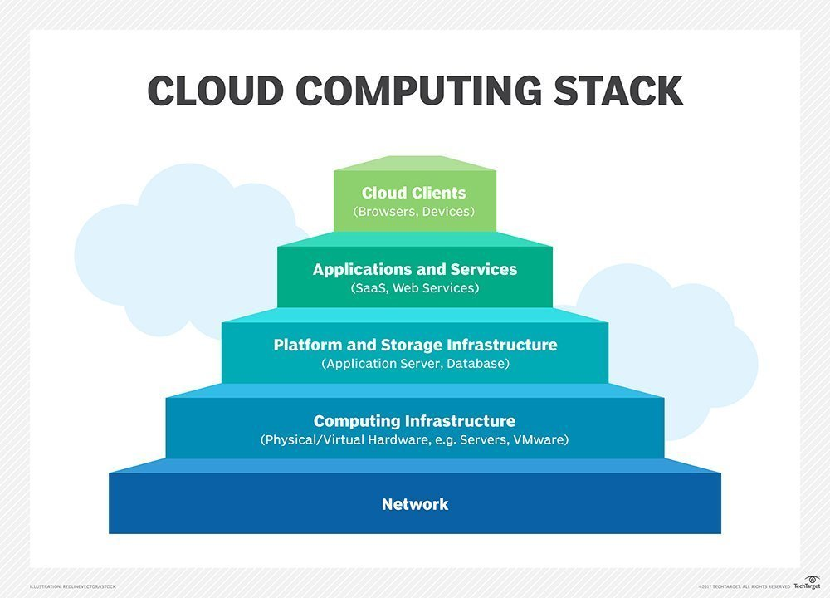

Infrastructure as a service (IaaS) is a type of cloud computing service that offers essential compute, storage, and networking resources on demand, on a pay-as-you-go basis.

**IaaS is one of the four types of cloud services**, along with software as a service ([SaaS](https://azure.microsoft.com/en-us/overview/what-is-saas/)), platform as a service ([PaaS](https://azure.microsoft.com/en-us/overview/what-is-paas/)), and [serverless](https://azure.microsoft.com/en-us/overview/serverless-computing/).

**Software as a service** (**SaaS**) is a way of delivering applications remotely over the internet instead of locally on machines (known as “on-premise” software)

**Software as a service (SaaS)**

allows users to connect to and use cloud-based apps over the Internet. Common examples are **email, calendaring and office tools** (such as Microsoft Office 365). SaaS provides a complete software solution which you purchase on a pay-as-you-go basis from a cloud service provider.

Salesforce is the leading **SaaS** provider with its flagship CRM platform, available exclusively online, as well as its SaaS platforms for marketing, service, and the Internet of Things. A

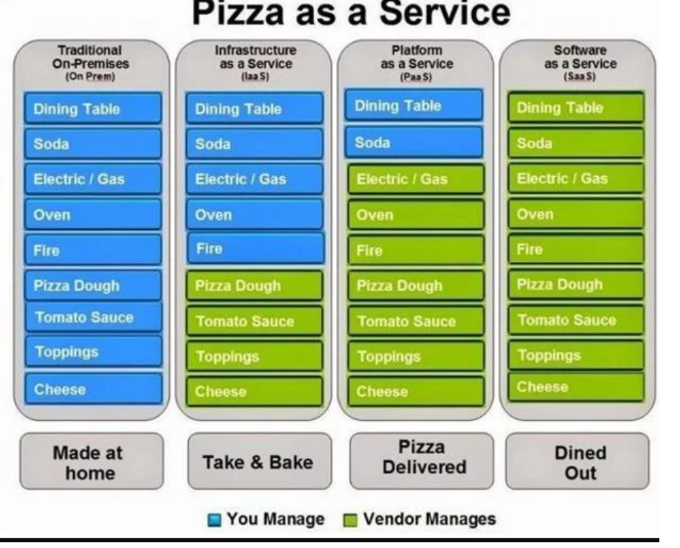

**Platform as a service (PaaS)**

With PaaS, you deploy your application into an application-hosting environment (designed for building, testing, and deploying software applications) provided by the cloud service vendor. Developers have multiple ways to deploy their applications without knowing anything about what's happening in the background to supporting it.

**Example** Web Apps feature in Azure App Service and Azure Cloud Services (web and worker roles) are an example of PaaS.

**Infrastructure as a service (IaaS)**

An IaaS cloud vendor runs and manages server farms running virtualization software, enabling you to create VMs (running Windows or Linux) that run on the vendor’s infrastructure and install anything you want on it. Developers don’t have control over the hardware or virtualization software, but they have control over almost everything else. In fact, unlike PaaS, you are completely responsible for it.

[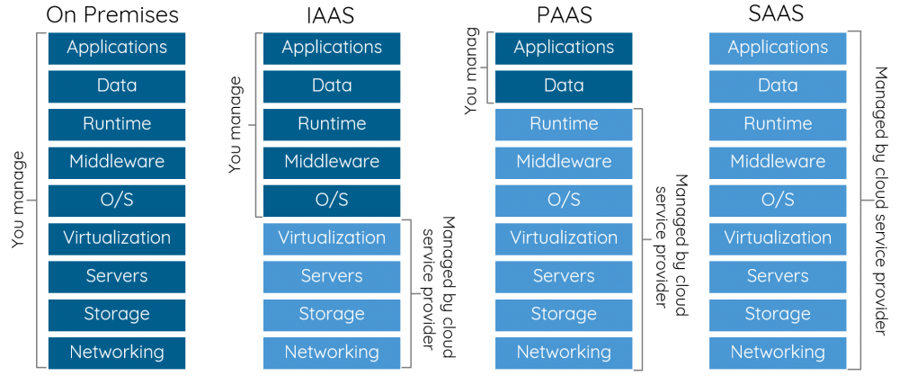](https://i.stack.imgur.com/K8MJA.png)

**References**

**Book**: Architecting the Cloud: Design Decisions for Cloud Computing Service Models (SaaS, PaaS, and IaaS)

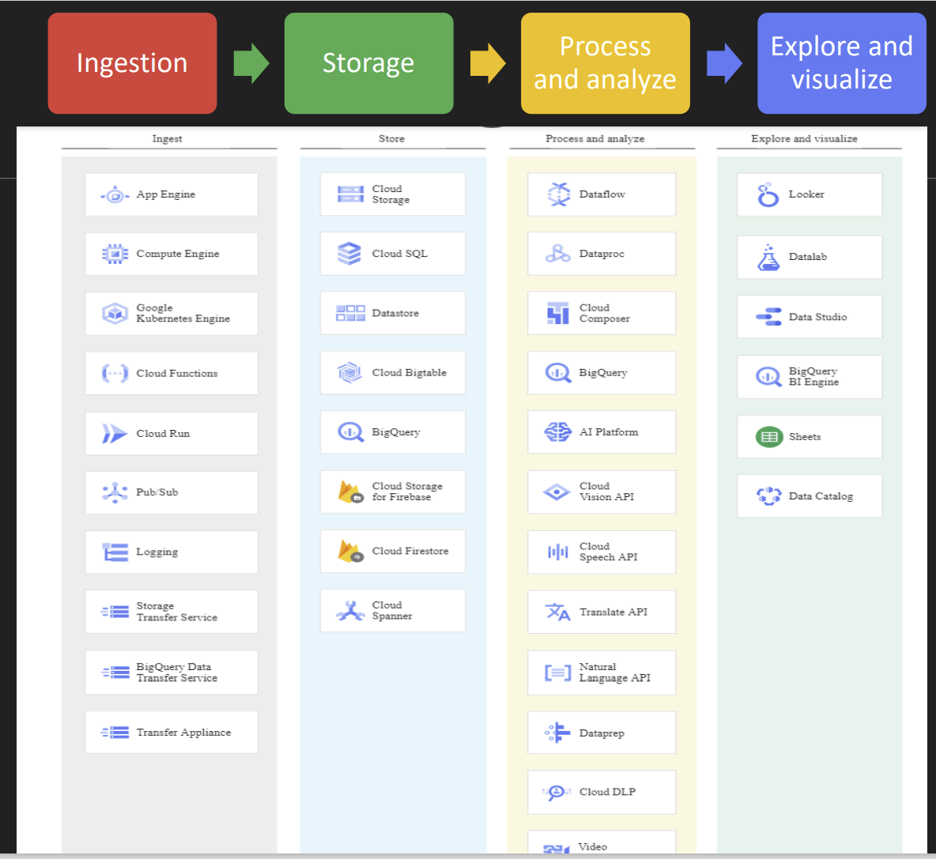

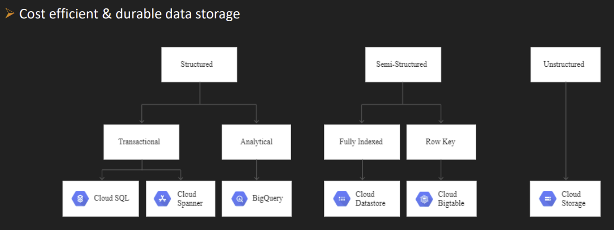

[Data lifecycle  |  Cloud Architecture Center  |  Google Cloud](https://cloud.google.com/architecture/data-lifecycle-cloud-platform#store)

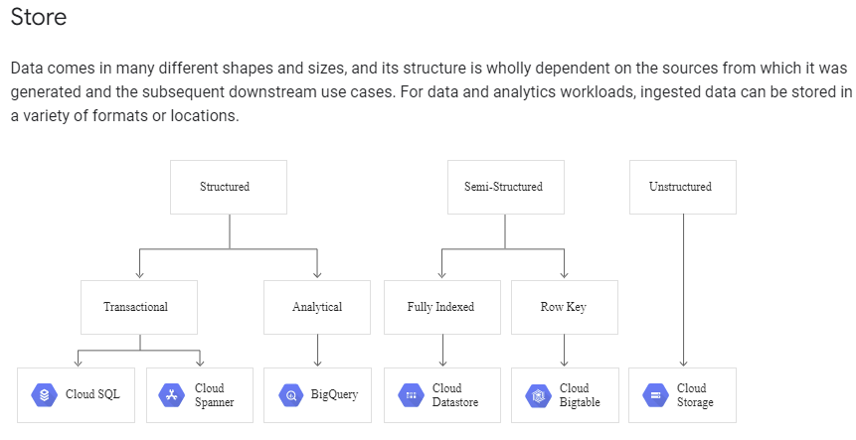

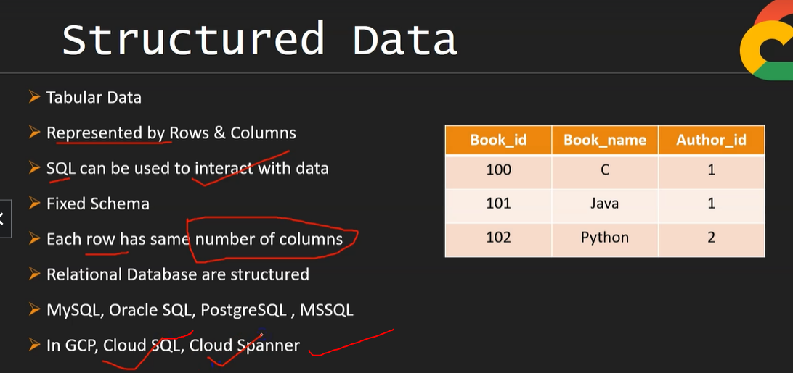

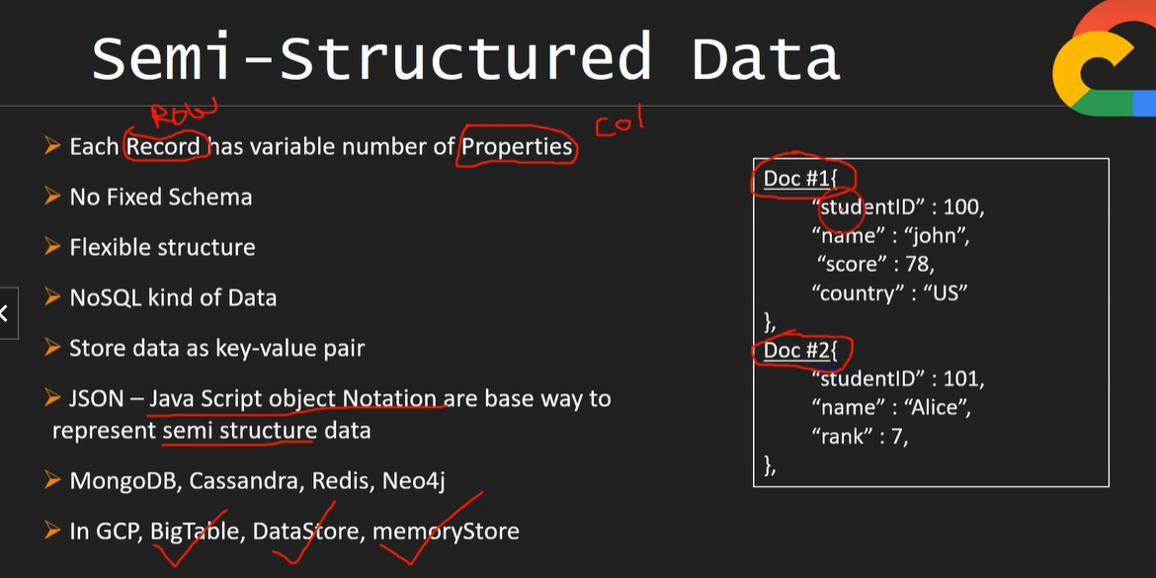

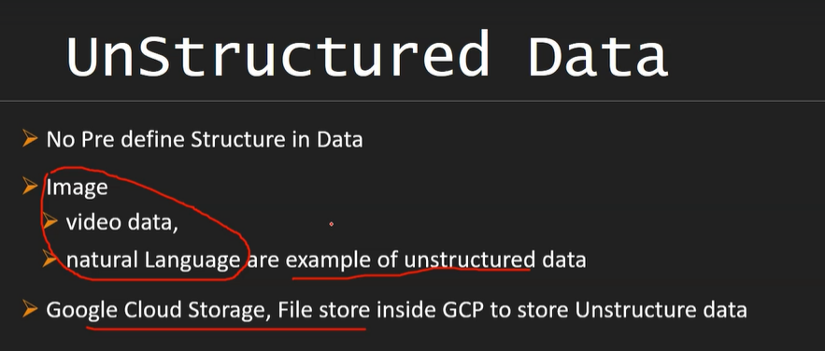

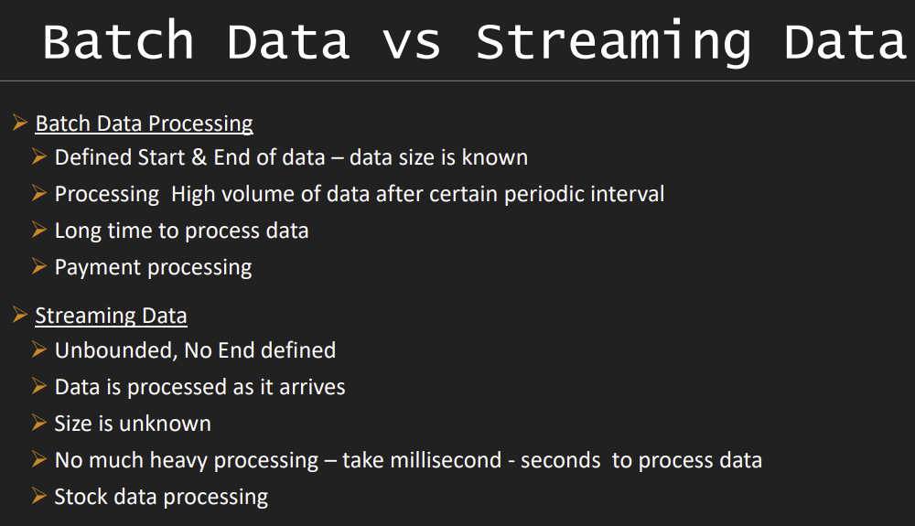

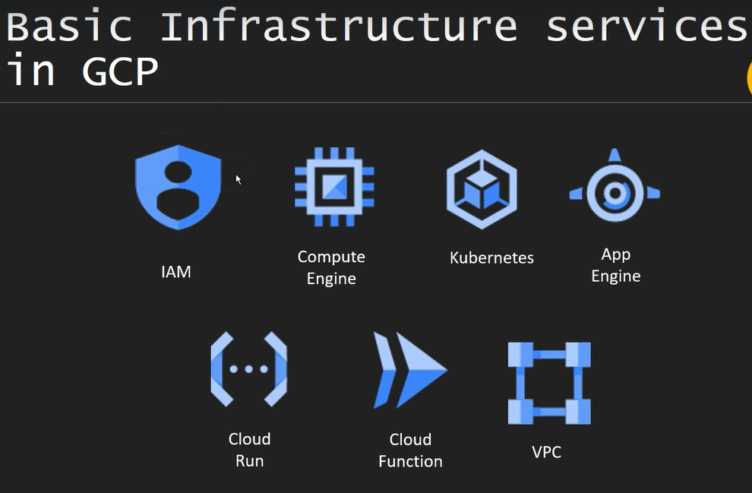

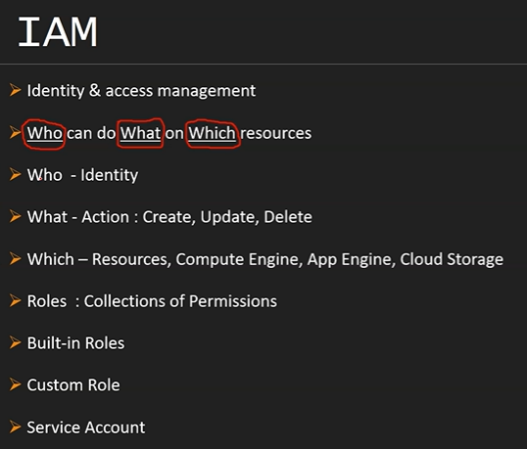

WHO 🡪

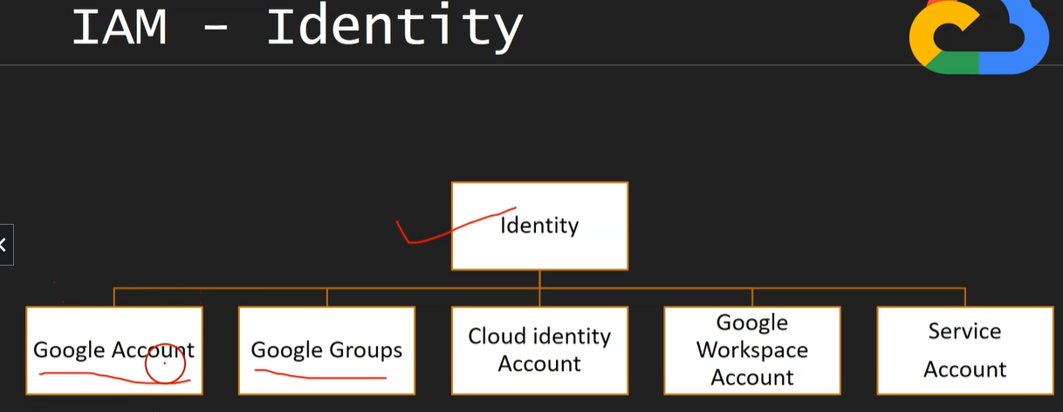

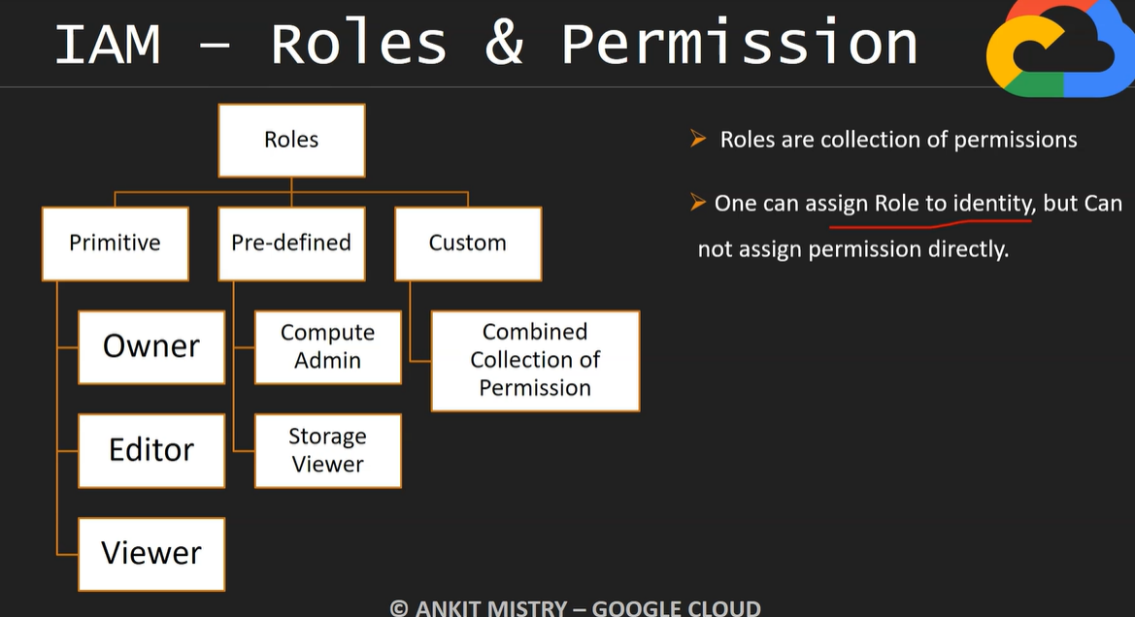

Total Roles are 1005 in GCP

Compute admin role 🡪

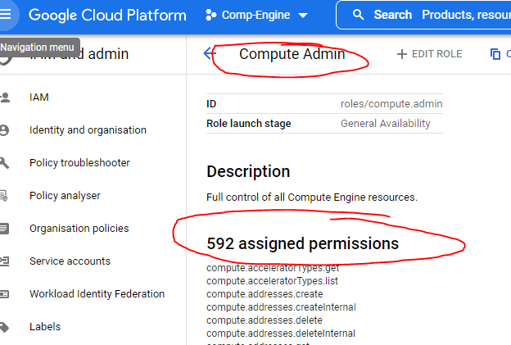

Owner roles🡪

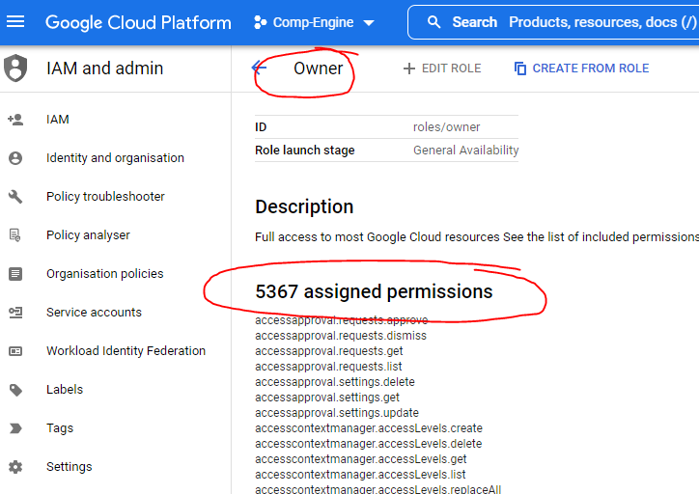

Editor roles🡪

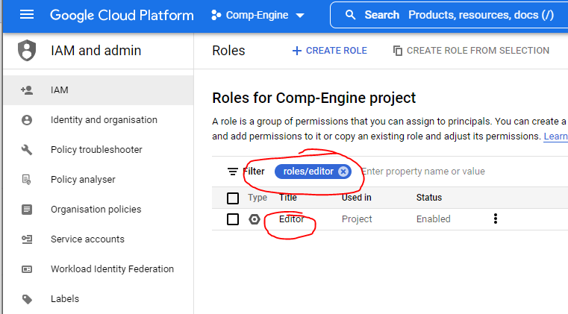

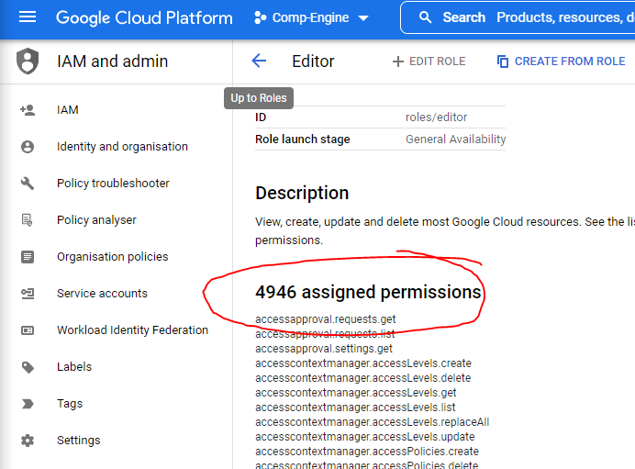

Viewer role🡪

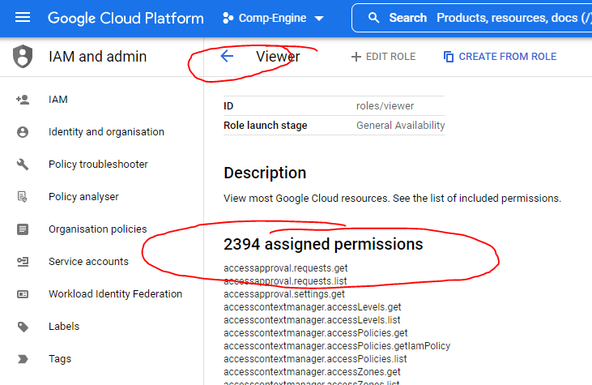

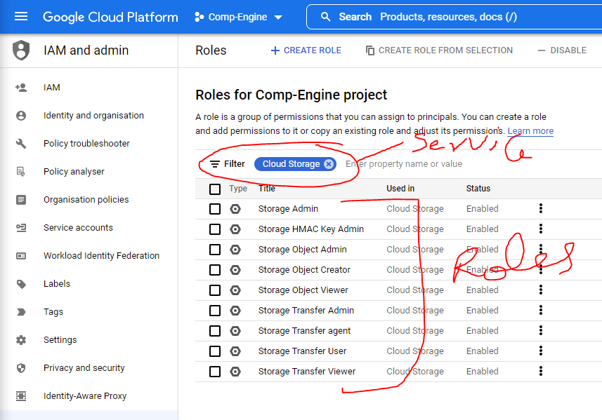

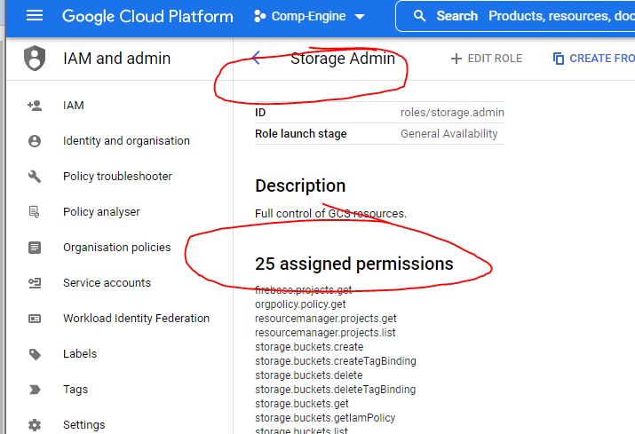

We can find how amny roles are assigned ,like **used in :Bigquery**

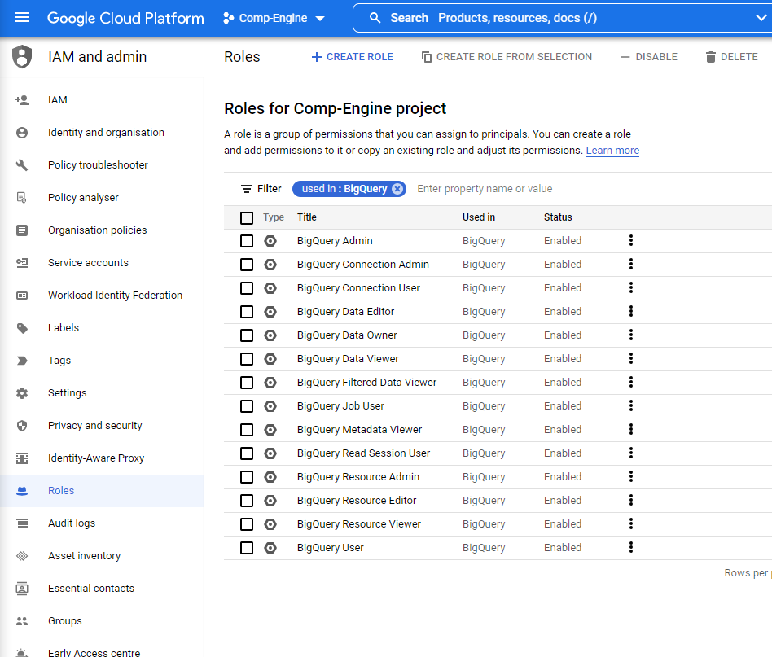

**Assigned roles to identity 🡪**

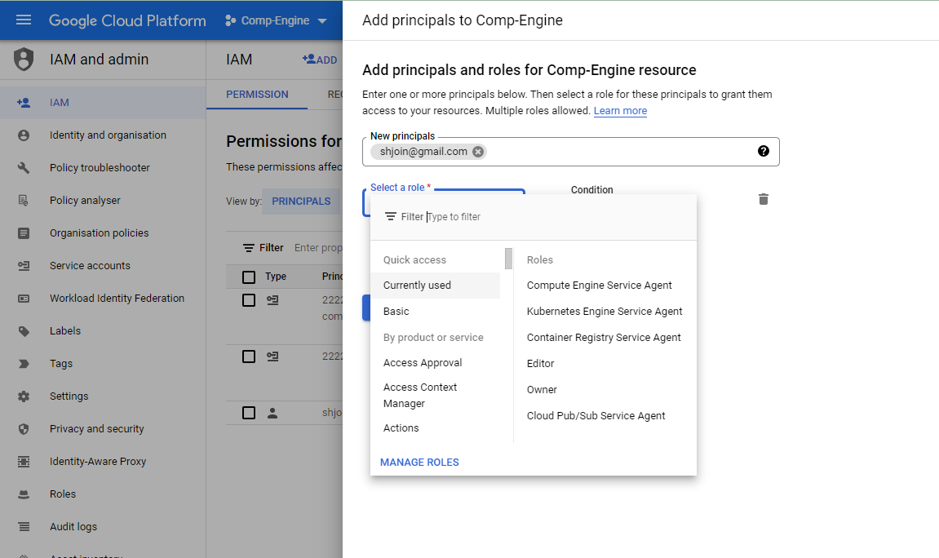

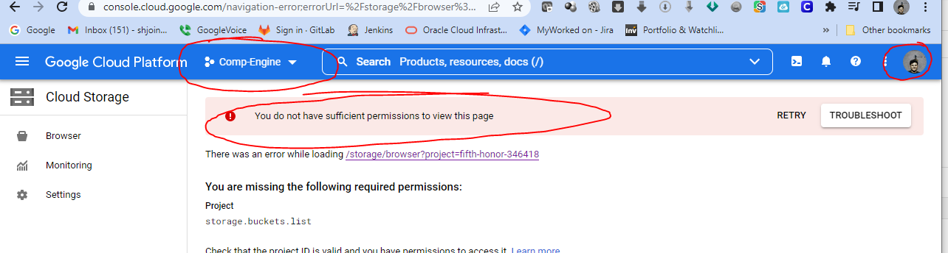

**SWervice account 🡪**

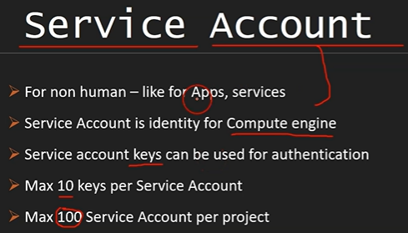

[**myservice-account@fifth-honor-346418.iam.gserviceaccount.com**](mailto:myservice-account@fifth-honor-346418.iam.gserviceaccount.com)

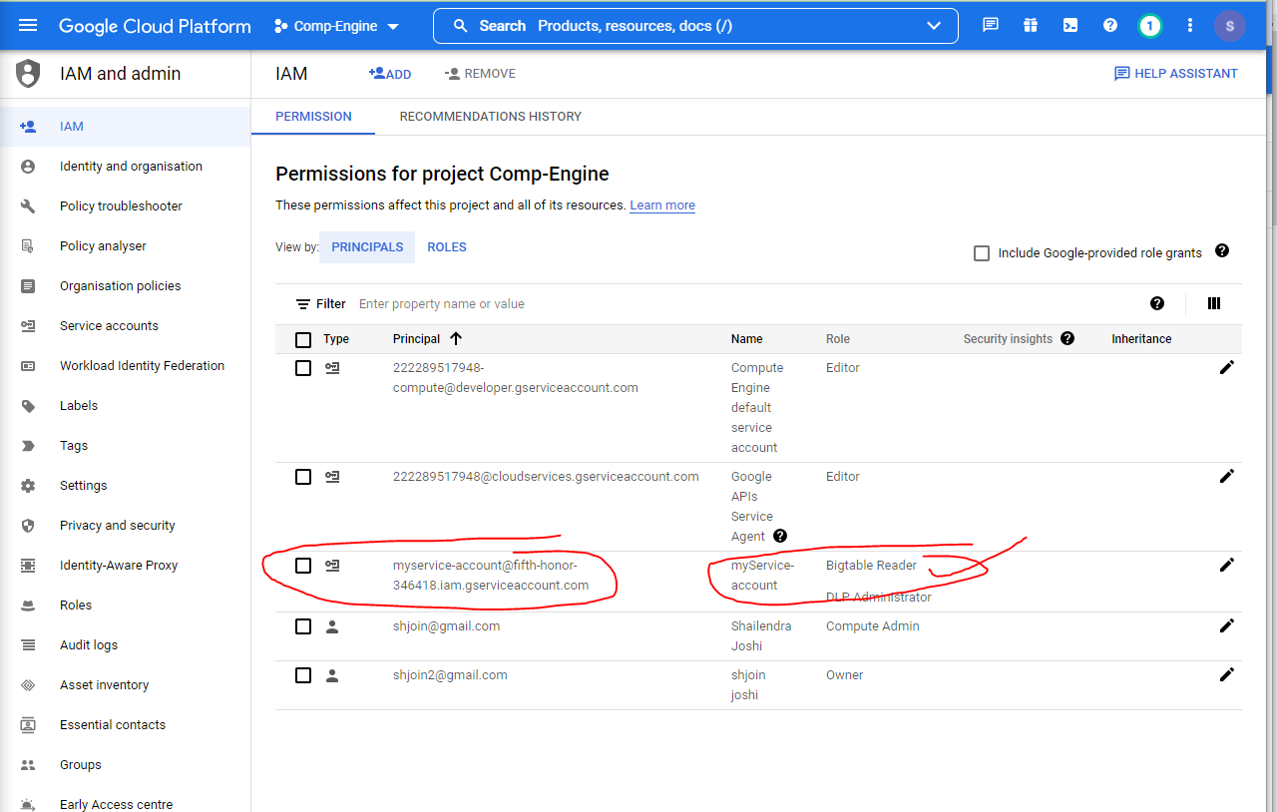

**Virtual machine🡪**

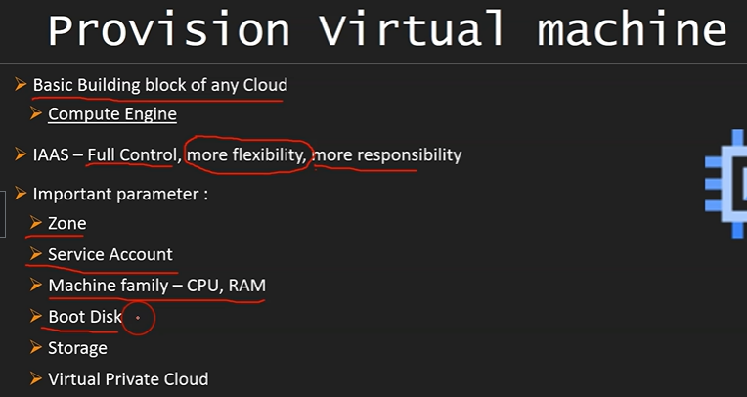

**Google app Engine🡪Serverless**

**PAAS**

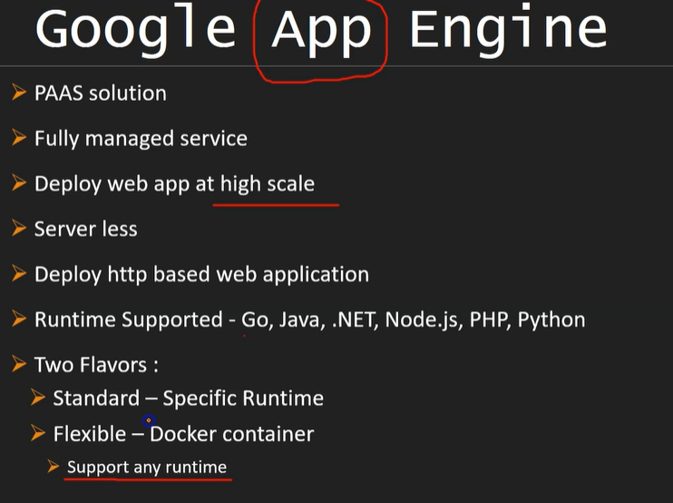

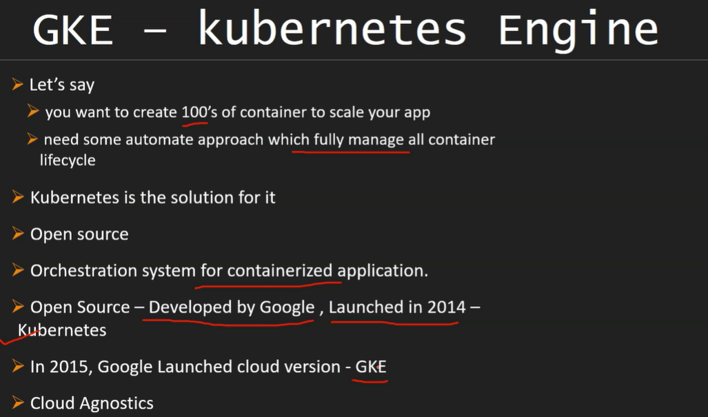

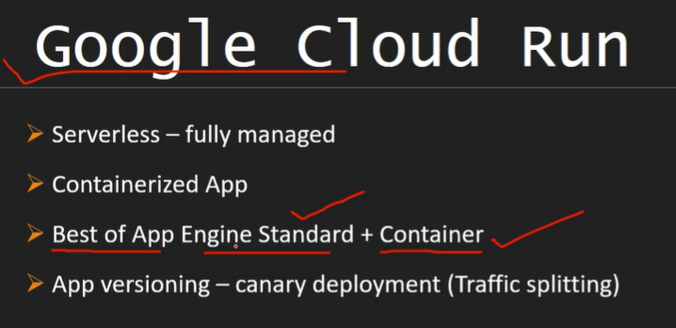

<https://cloud.google.com/run>

<https://cloud.google.com/run#all-features>

Develop and deploy highly scalable containerized applications on a fully managed serverless platform.

##### Leverage container workflows and standards

Containers have become a standard to package and deploy code and its dependencies. Cloud Run pairs great with the container ecosystem: [Cloud Build](https://cloud.google.com/cloud-build), [Cloud Code](https://cloud.google.com/code), [Artifact Registry](https://cloud.google.com/artifact-registry), and [Docker](https://www.docker.com/).

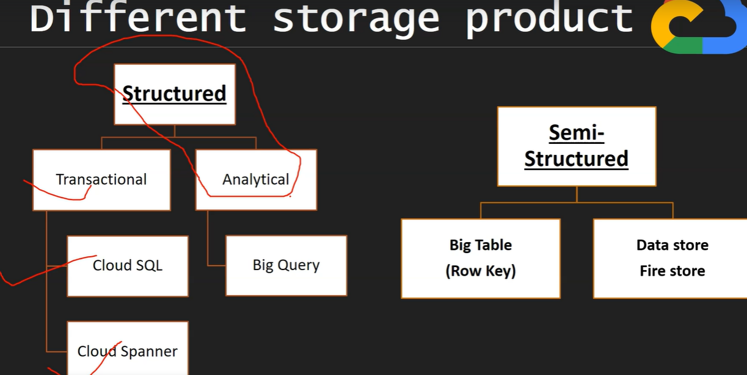

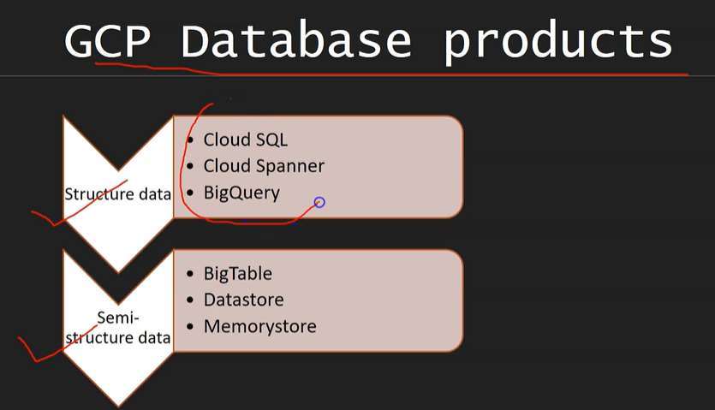

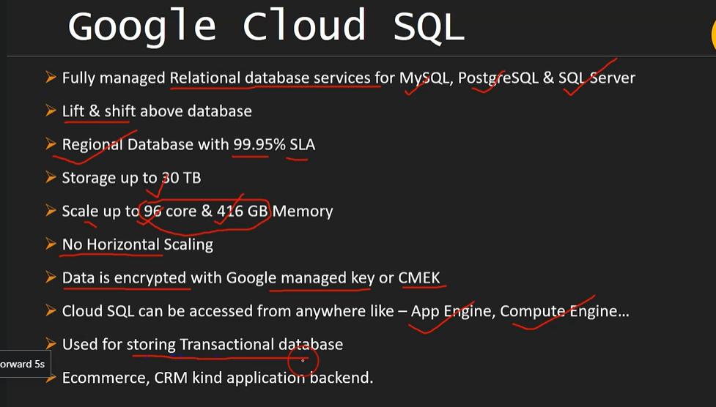

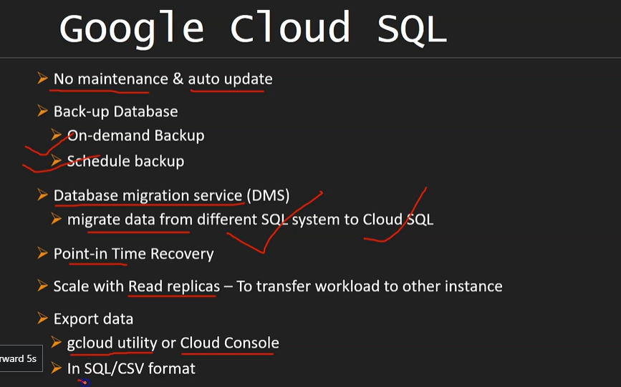

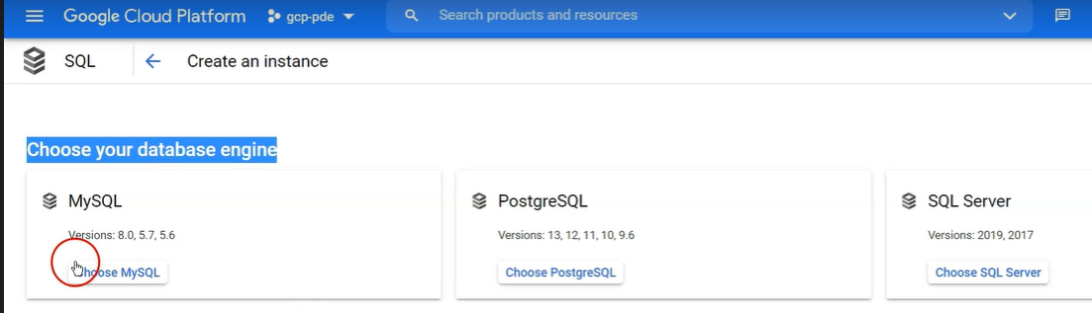

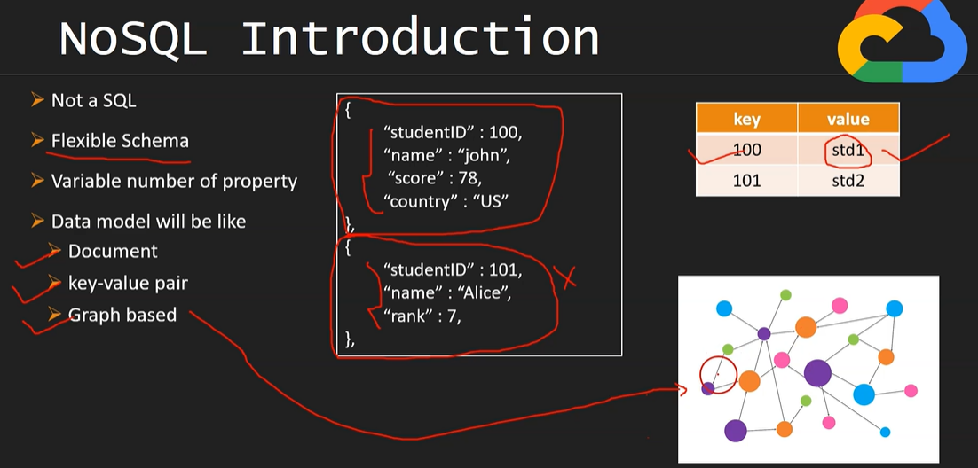

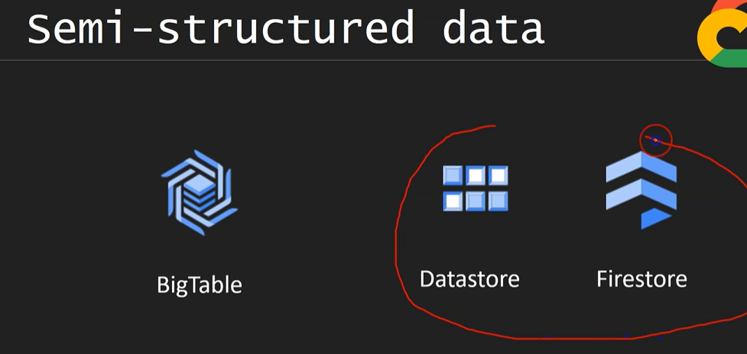

Google Cloud Datastore is a highly scalable, fully managed NoSQL database service offered by Google on the Google Cloud Platform. Cloud storage is something that "allows you to save data and files in an off-site location that you access either through the public internet or a dedicated private network

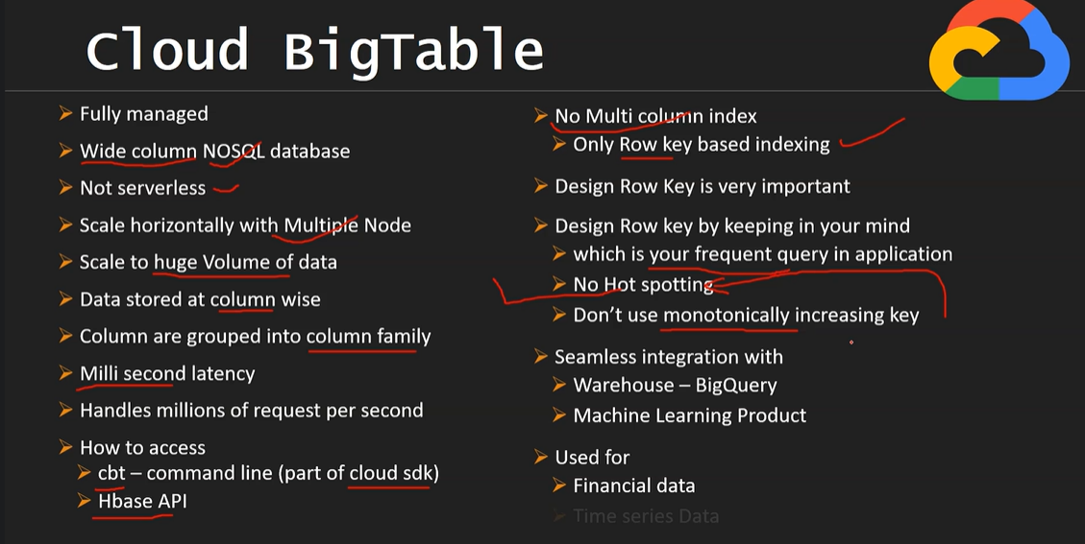

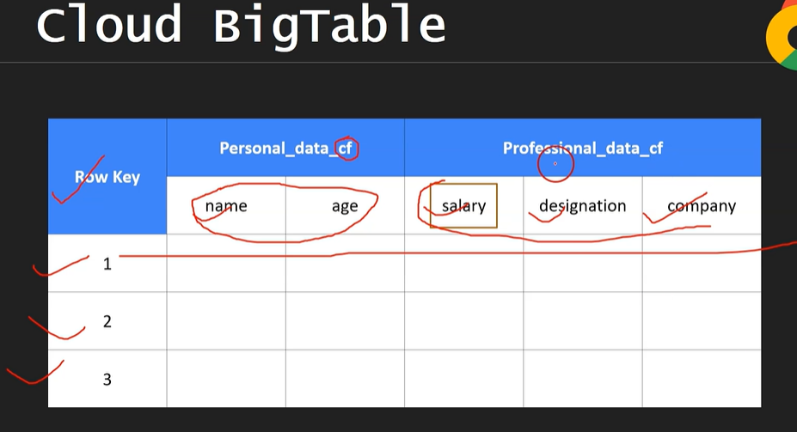

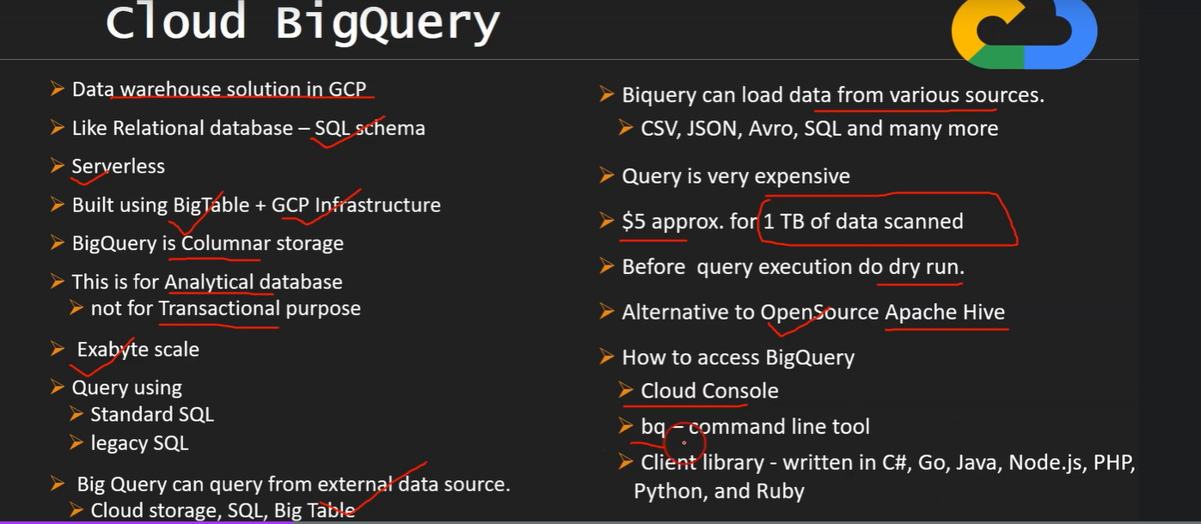

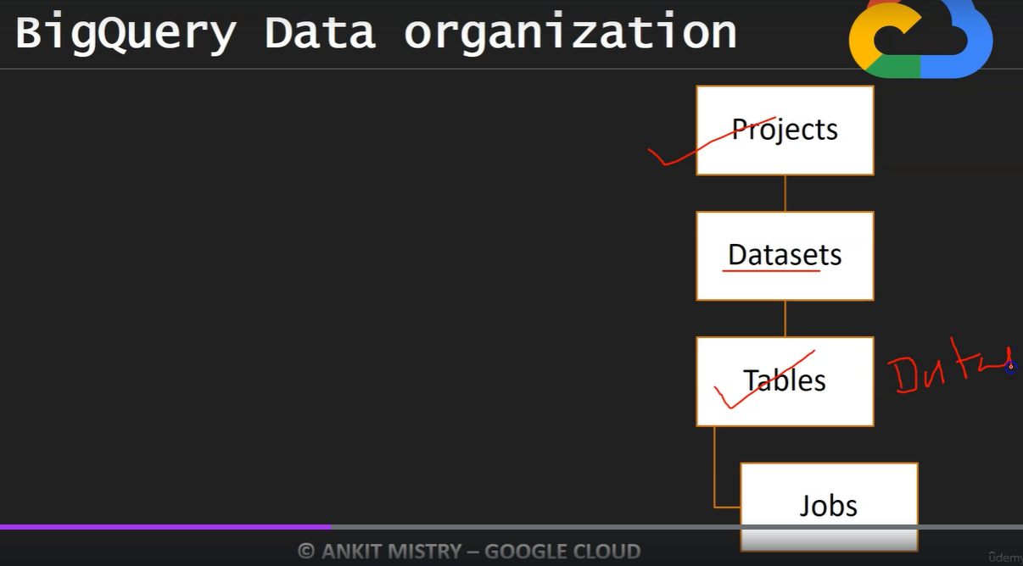

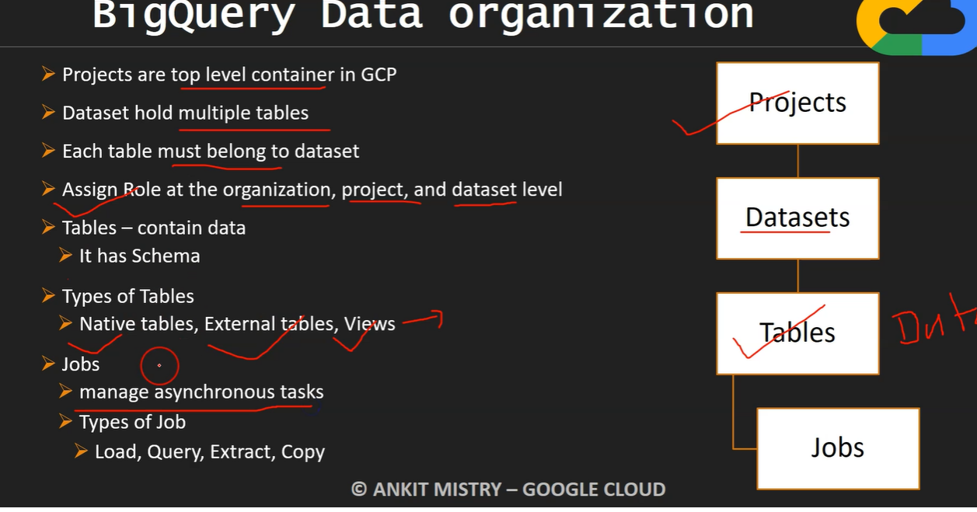

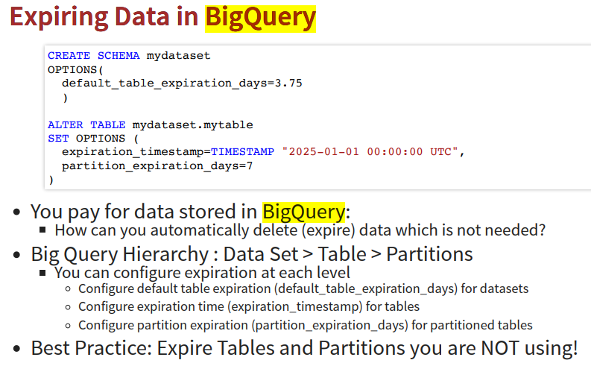

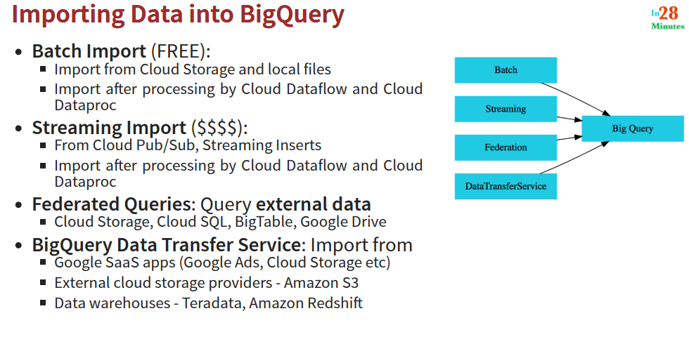

Batch imort is Free .

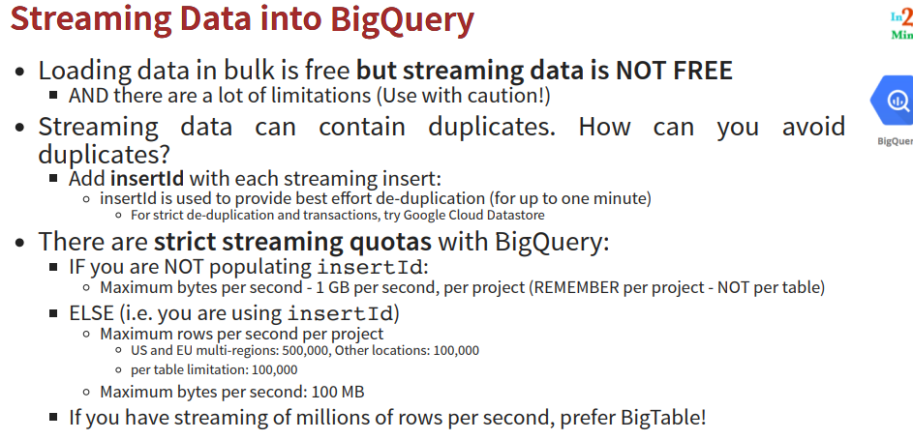

Before run need tocheck dry run any SQL

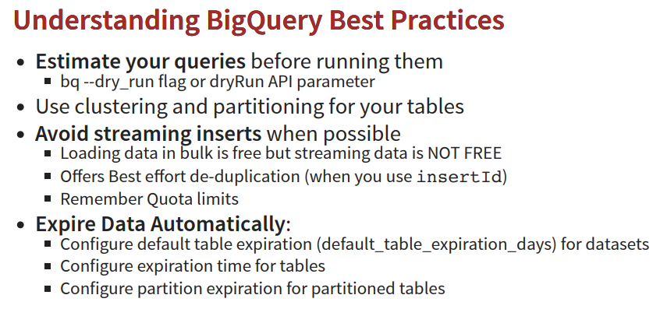

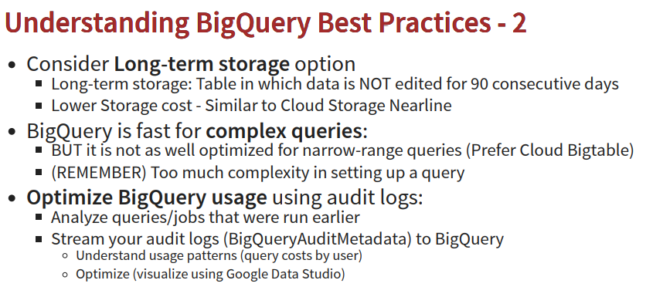

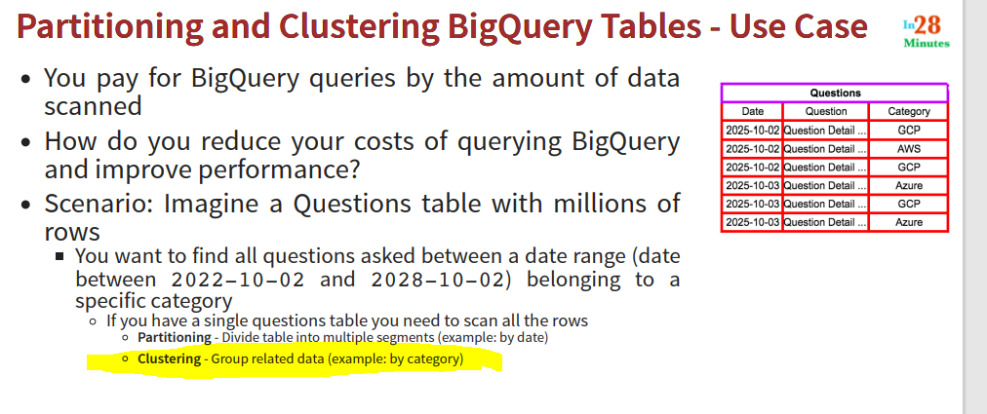

**Clustering** 🡪 **If MOST of partion are less than 1 GB ,in those kind of situation its better to go with CLUSTERING …**

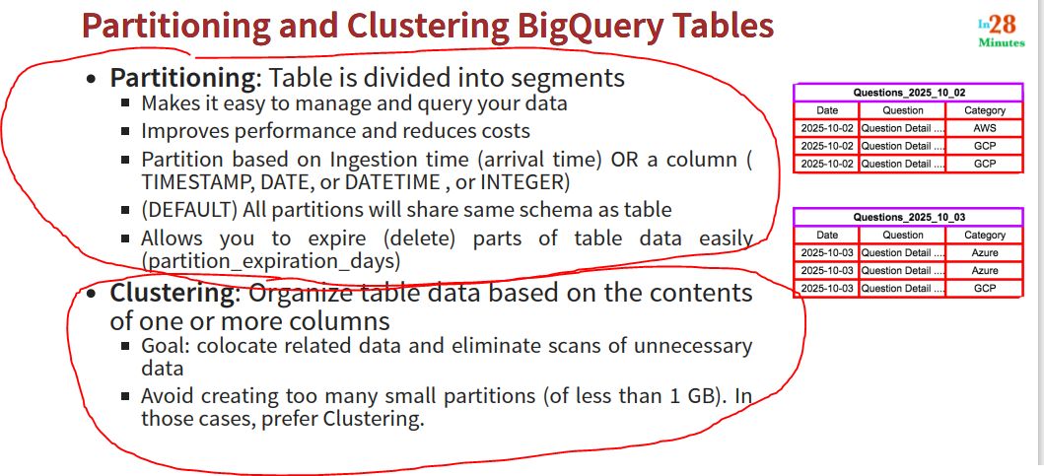

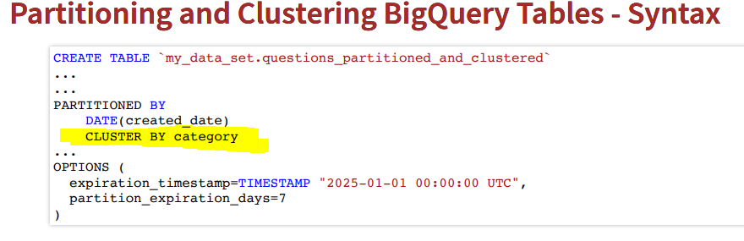

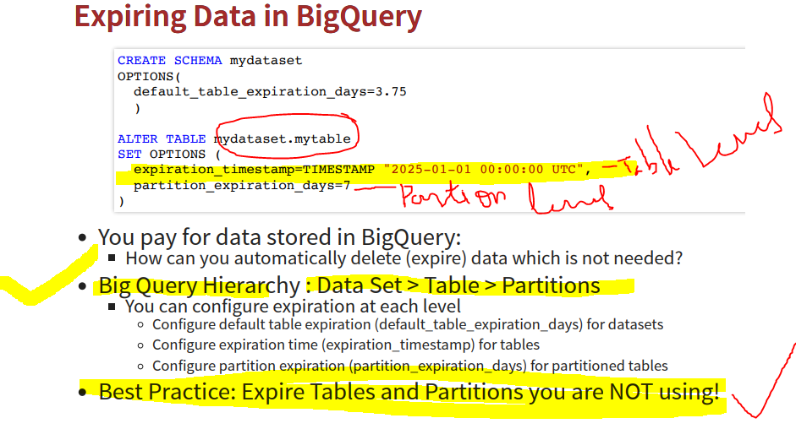

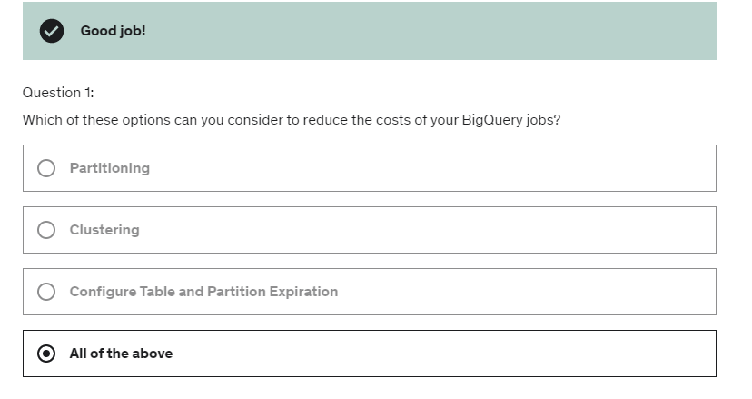

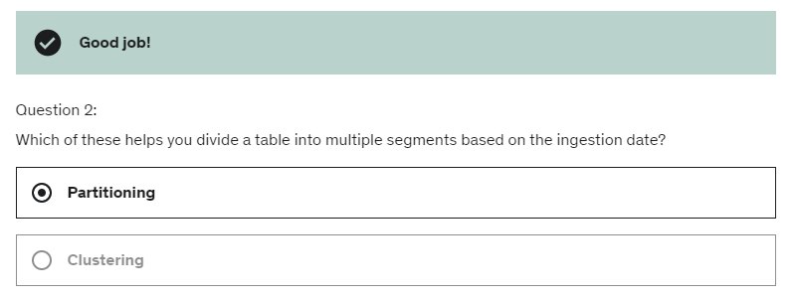

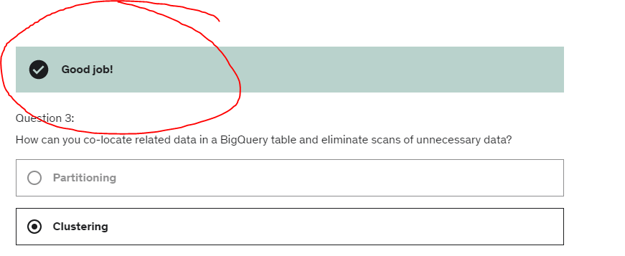

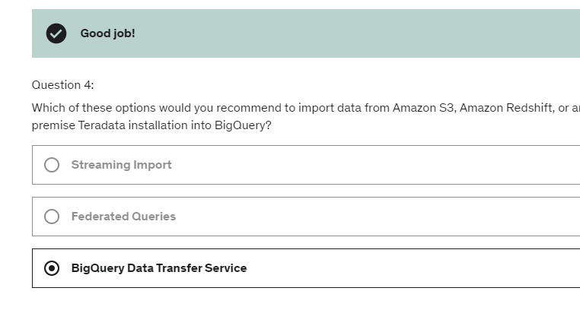

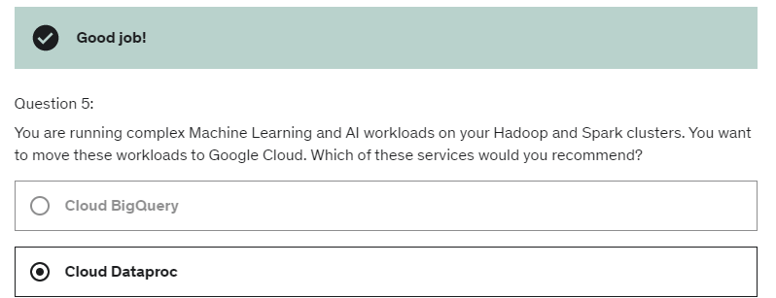

Google storage 🡪 Bucket

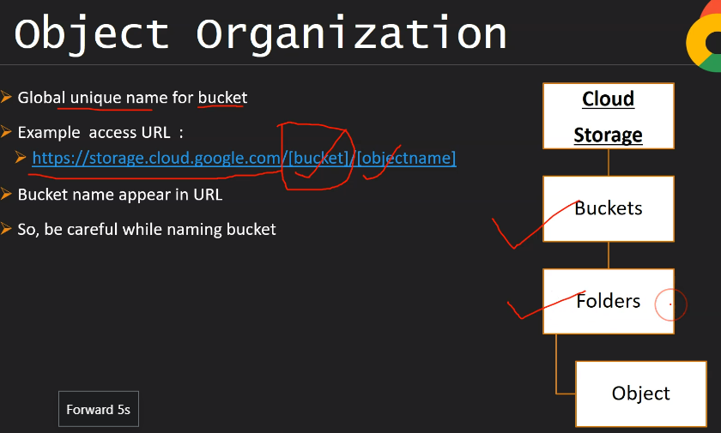

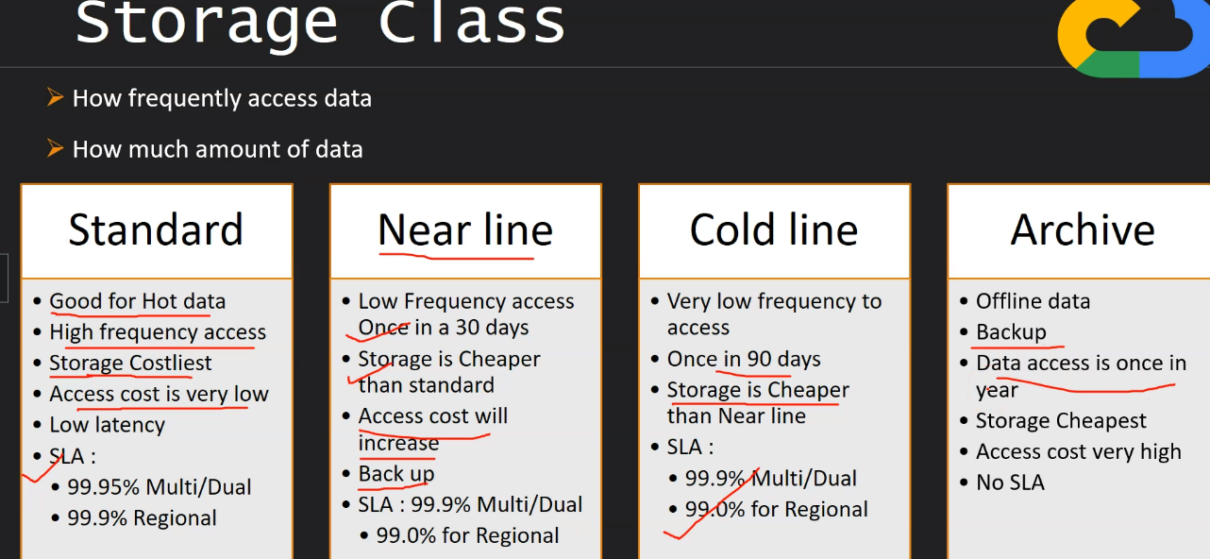

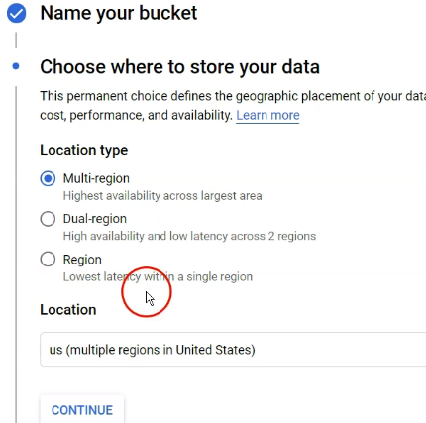

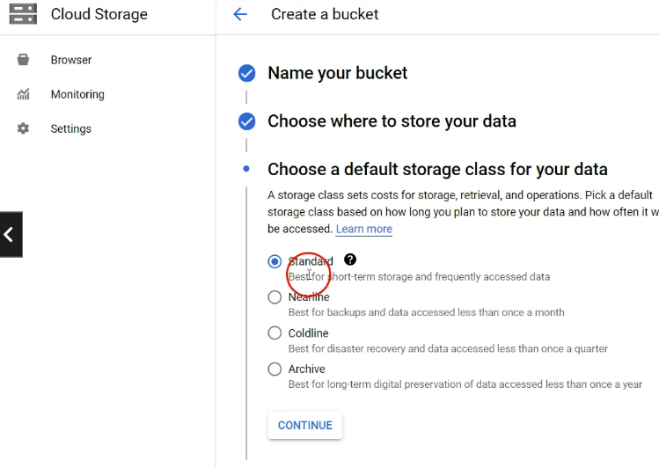

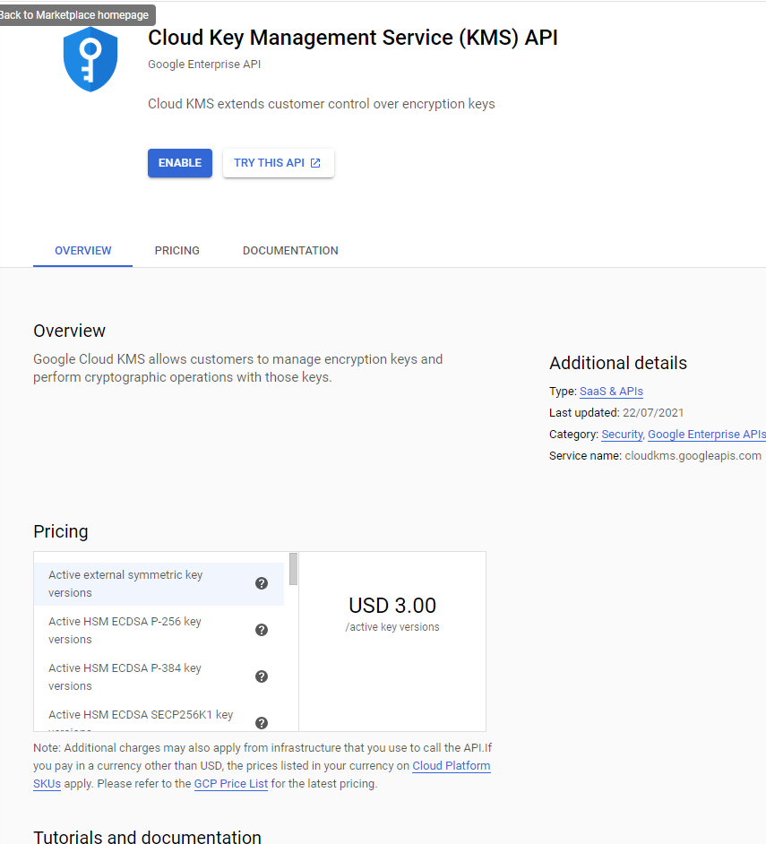

Genarate key



The same key I used for file in bucket

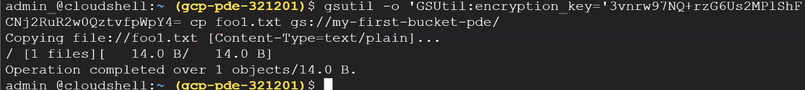

We can not access this file through cloud url

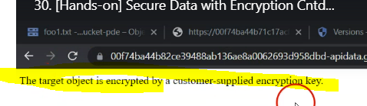

But we can see thgrough cloud shell with supply key

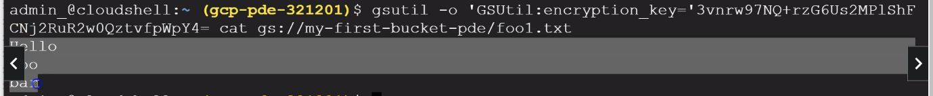

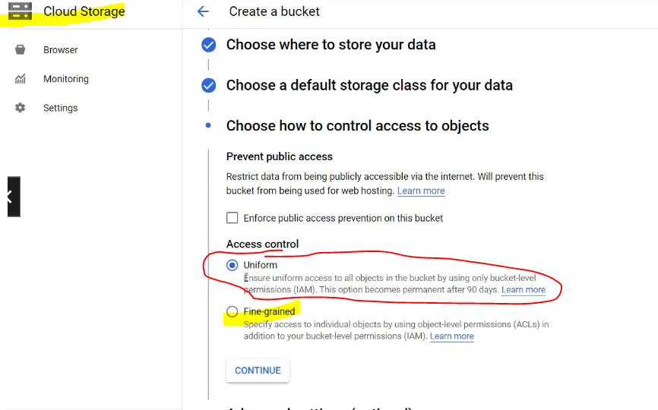

**Gloud storage : Access control**

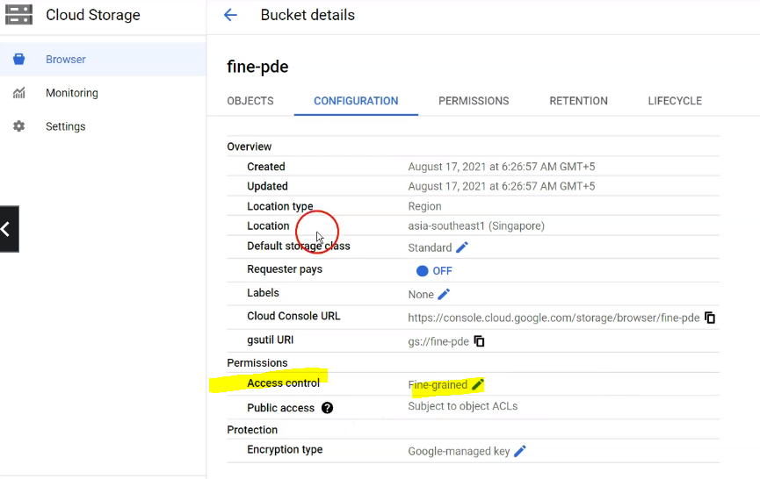

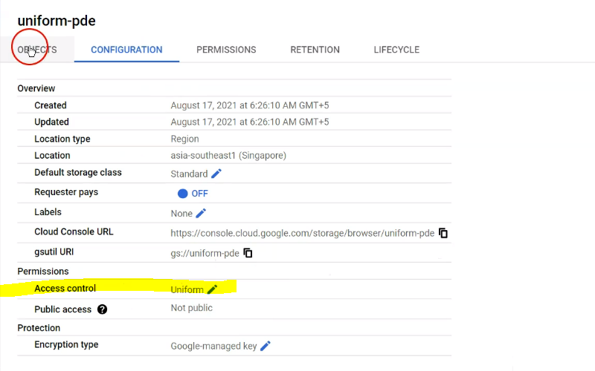

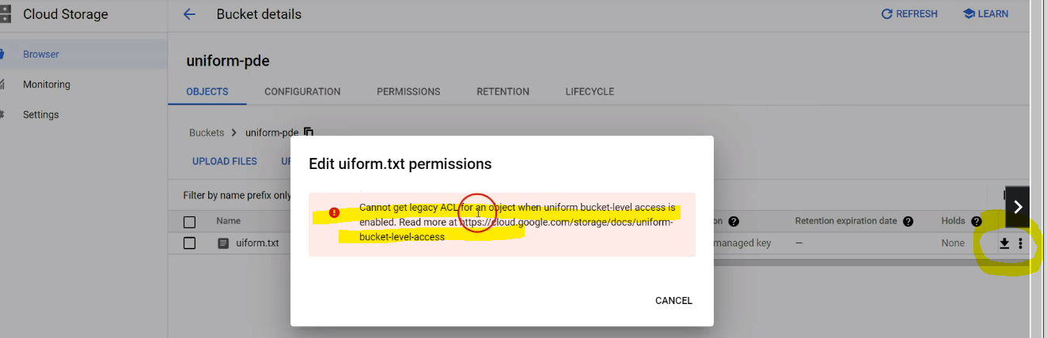

On object levele In uniform ACL we can not assigned diff ACL (add permission ) BUT we can do in Fine grained .

On bucket level permision option as below in unifoirm ,we can assign diff ACL on object level .

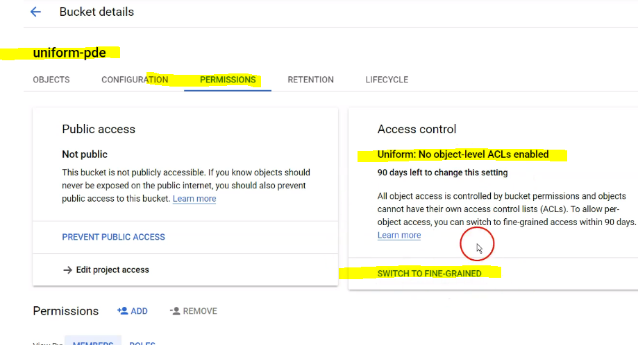

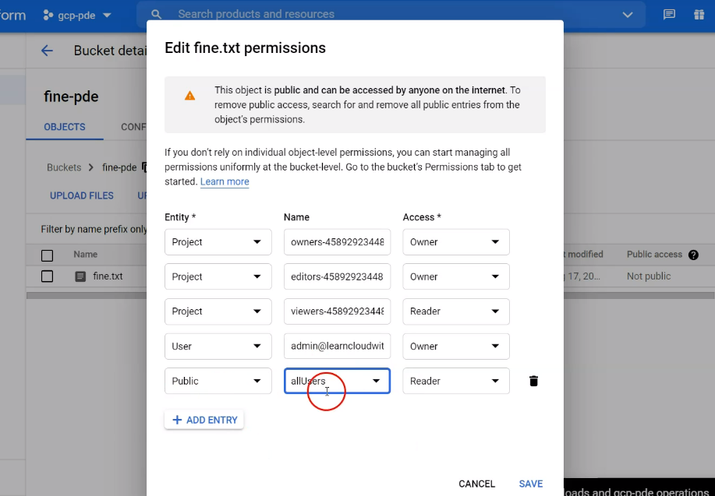

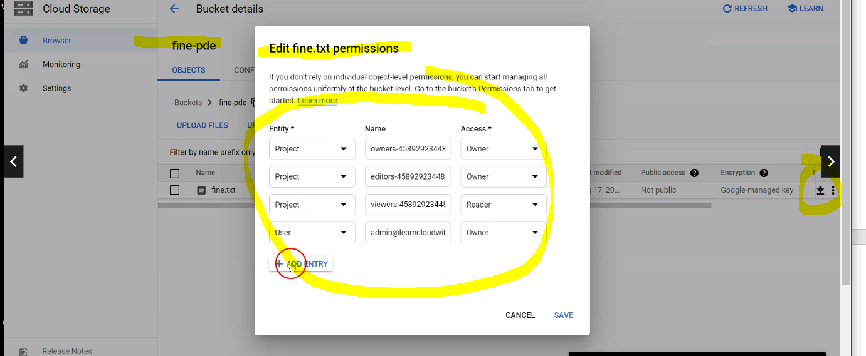

We can change

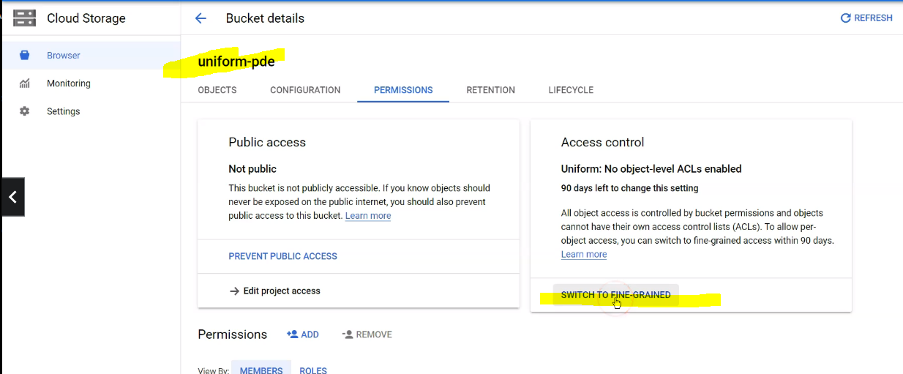finegraned access we can define access on each objects level

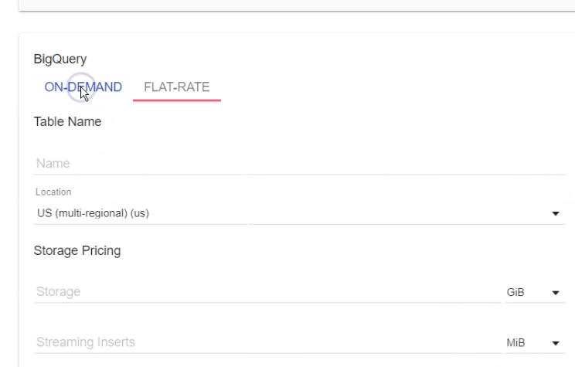

PUB/SUB🡪

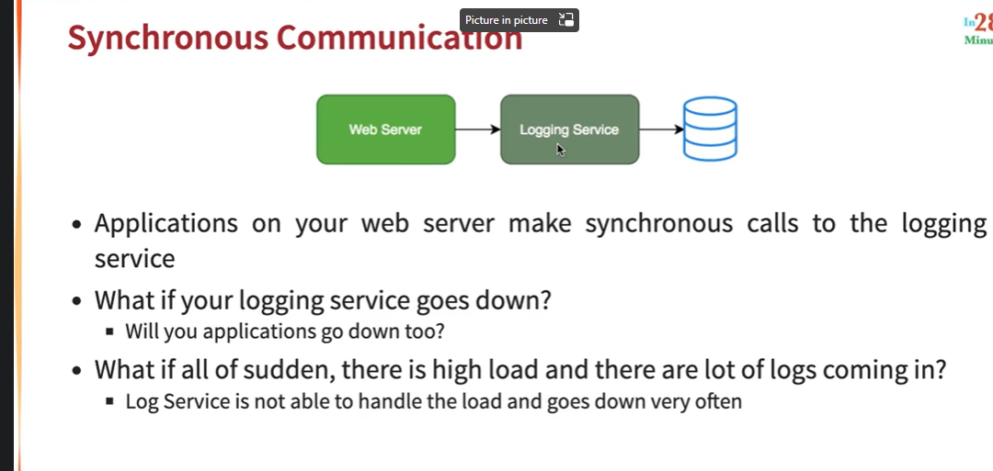

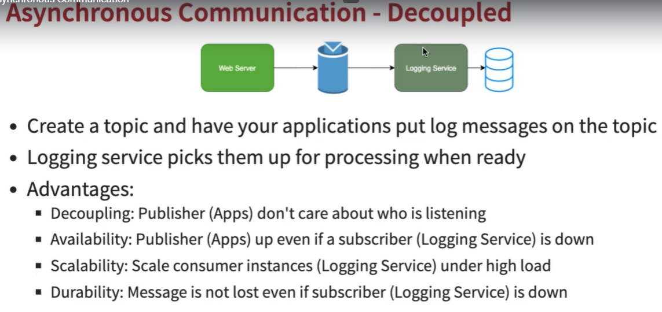

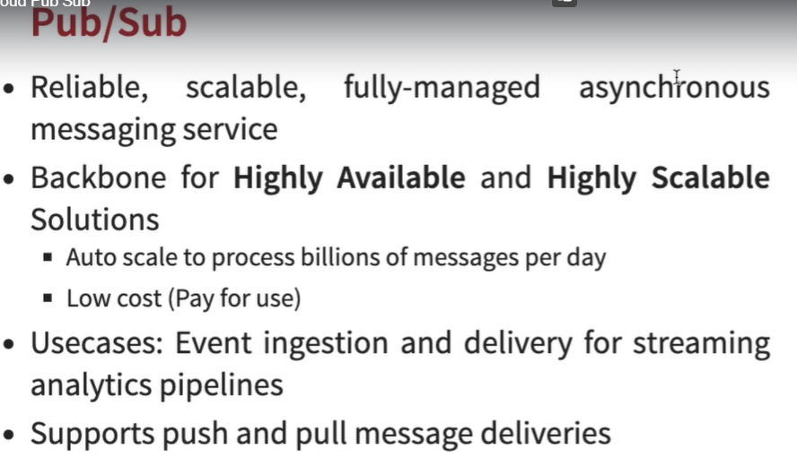

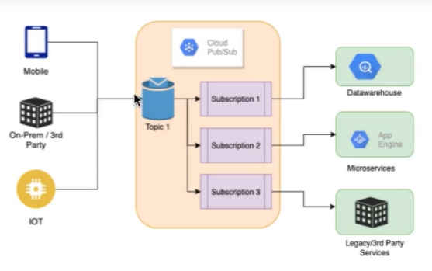

1. Create a topic
2. And to this topic , a no. of publishers (mobile/iot..) can send messages and a number of receivers or consumers (D/w,microservices..) can listen to the topics and process these messages though subscriptions .

Publishers send msges by making HTTPS requests to pubsub.goggleapis.com.

Subscriber – receiver of the message .two types of subcribers

Pull and push .

Pull 🡪 subscriber pulls messages from the topics ,whenever the subscriber is ready .

Subscriber makes HTTPS requests to pubsub.googleapis.com and topics respond back yes or no ?

Push 🡪as soon as a msg is sent by publishers to a topcs , the mgs is automatically sent out to all the subscribers when a subscribers is creating a subscription ,they would actually provide a webhook end point and the end point would be envoke as soon as as there is a msg on the topic,when the msg on the topic ,the https post request sent to the webhook end points

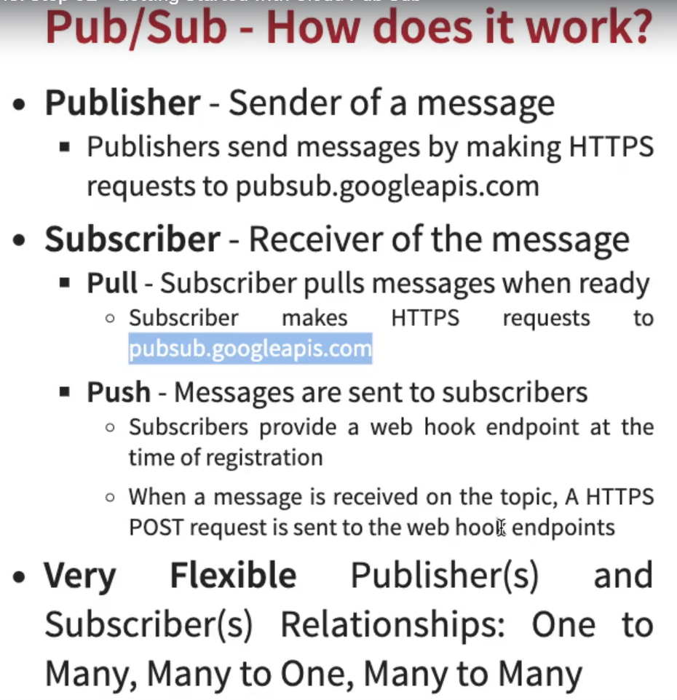

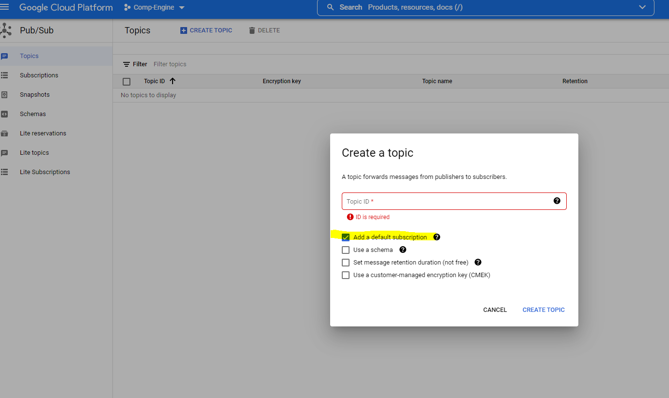

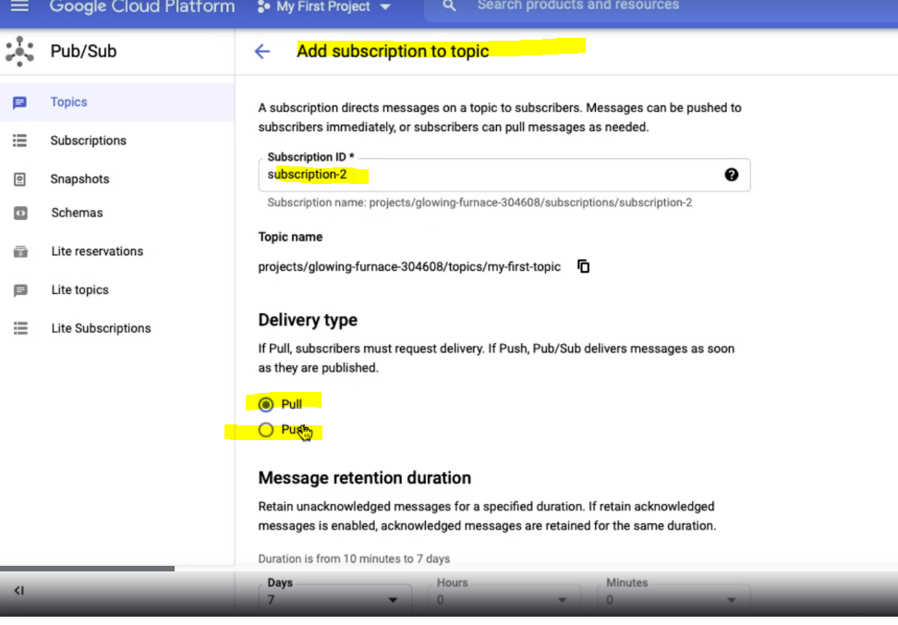

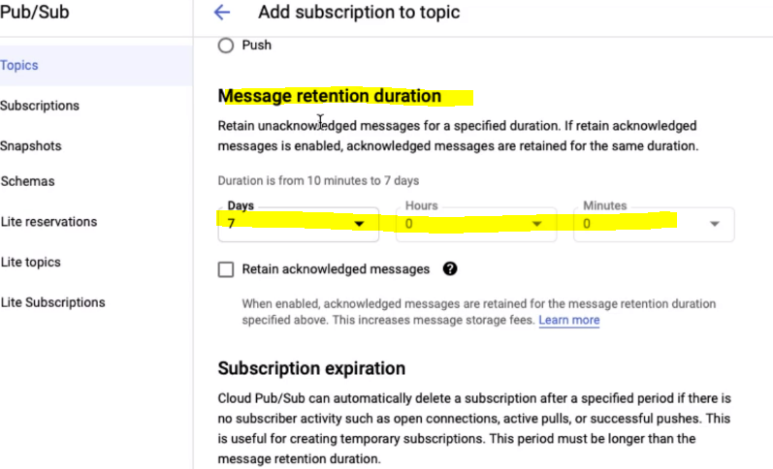

7 days the msg will store in a topic

Pull🡪 consumer will pull the subscription when they ask for it

Push 🡪 need endpoint url

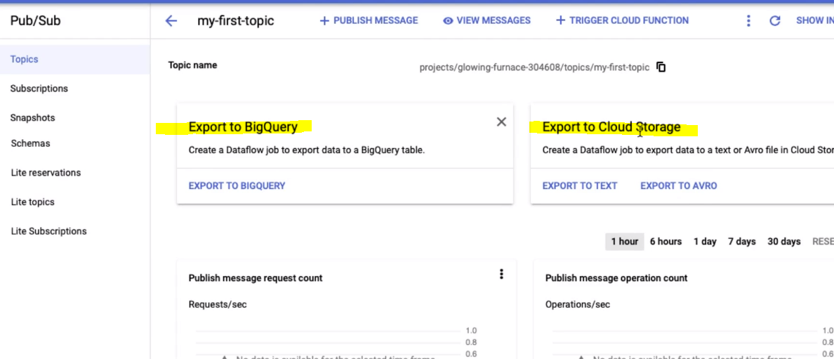

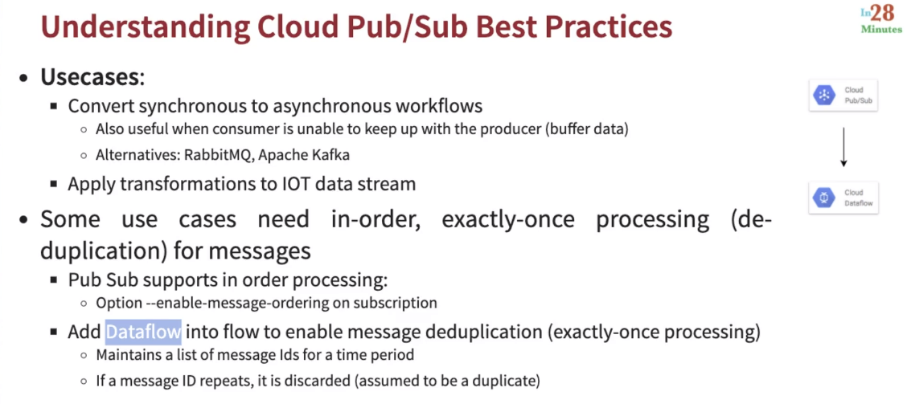

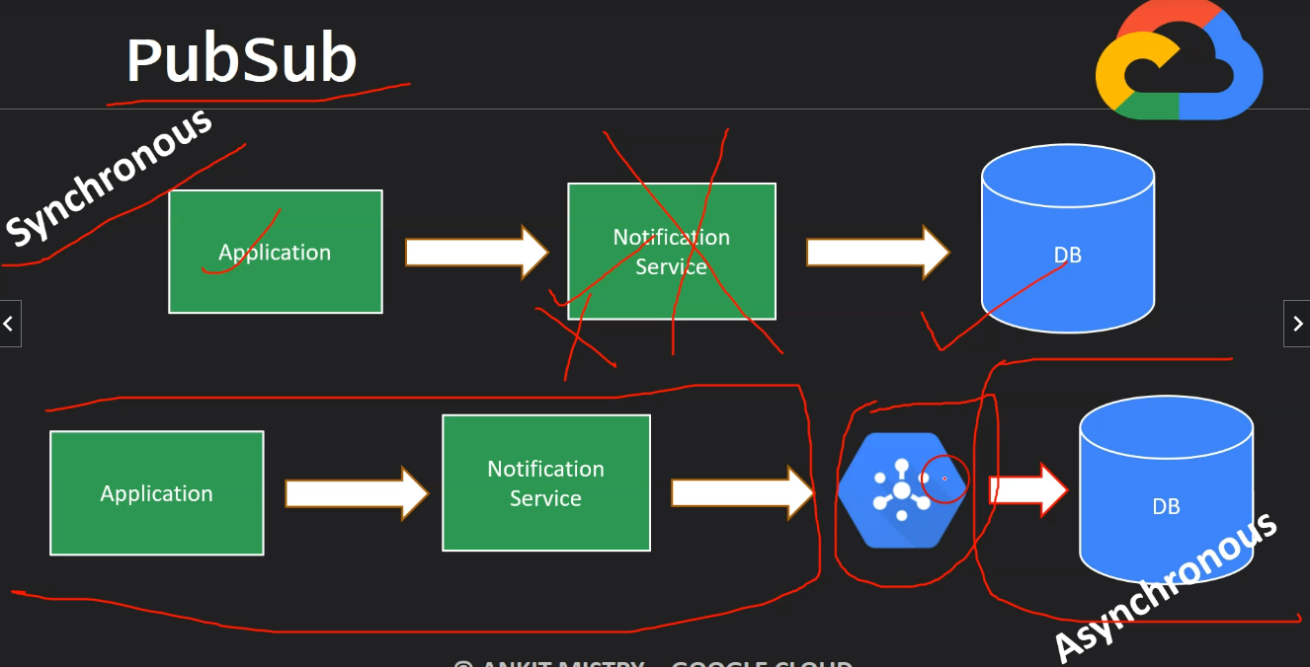

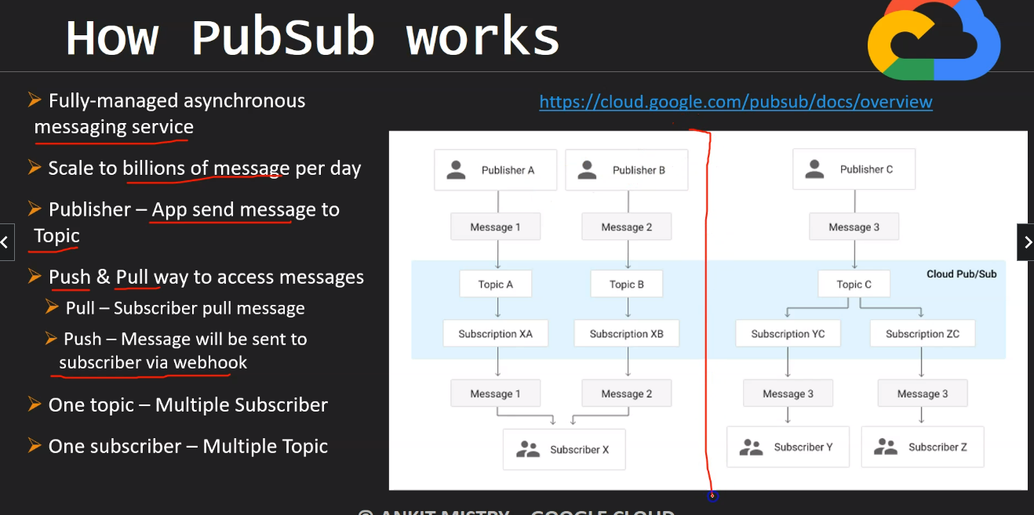

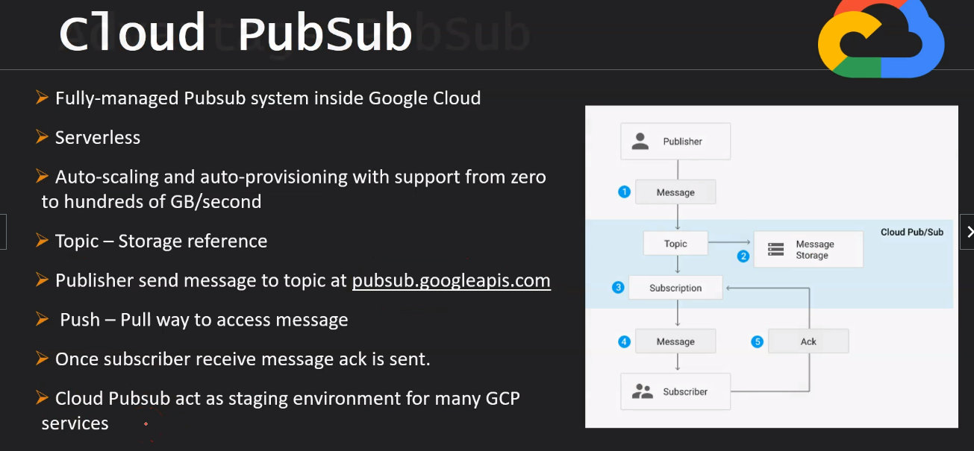

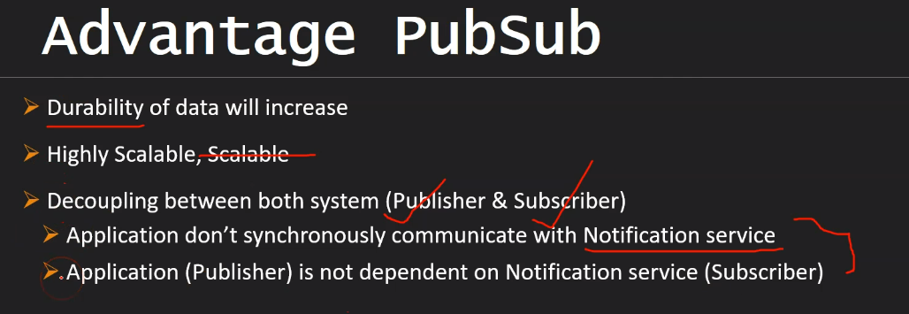

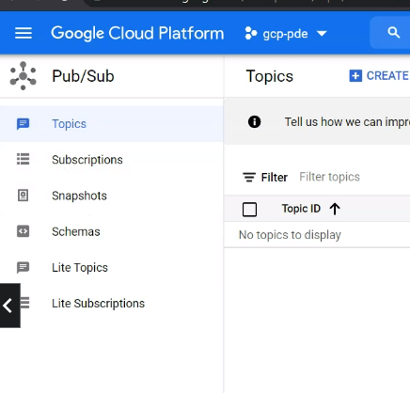

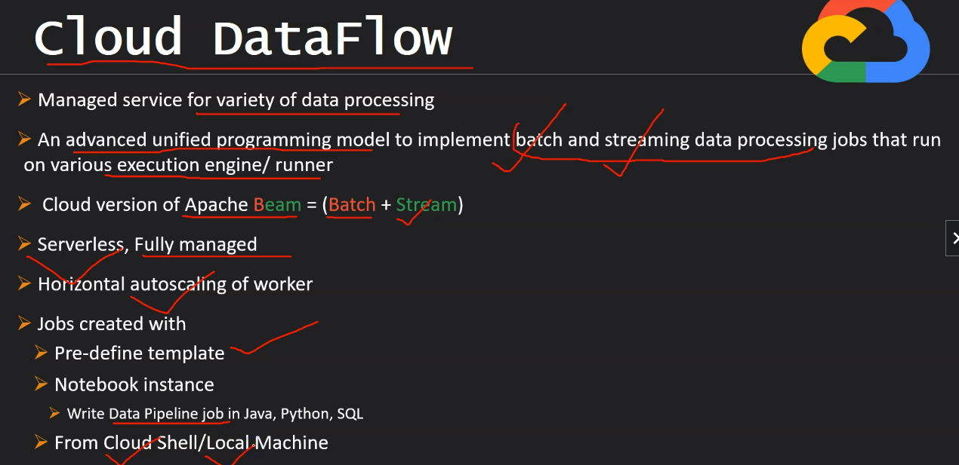

Data Proc🡪

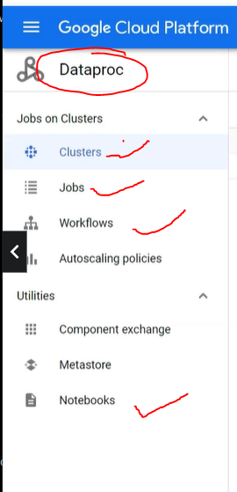

NOTEBOOK🡪Jupyter

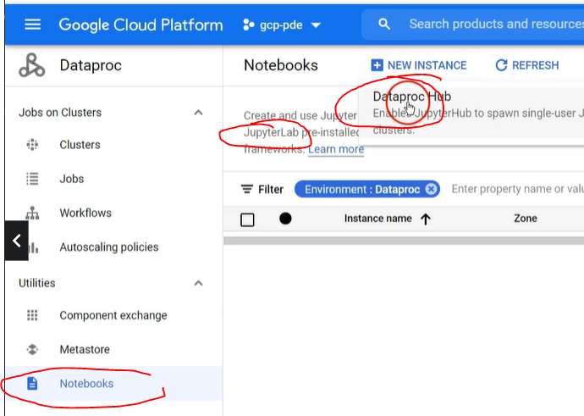

Need to create machine to run jupyter notebook

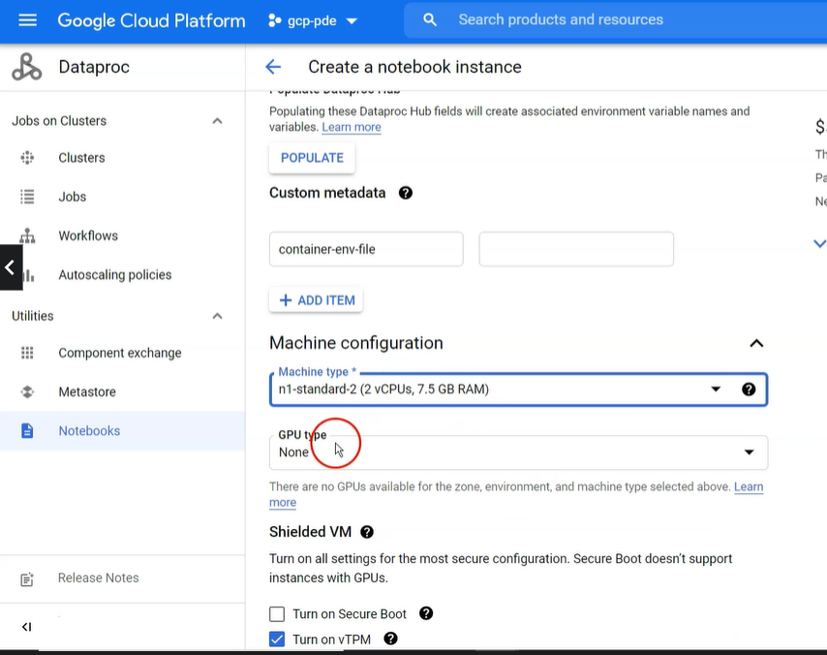

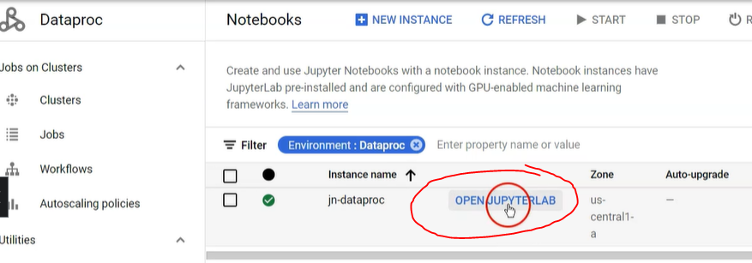

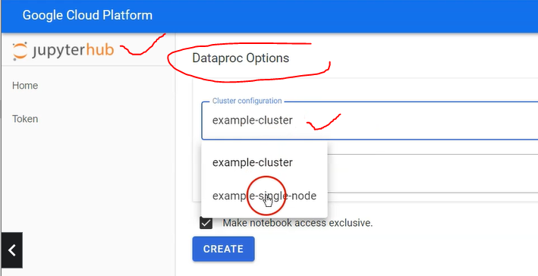

Now we need to create a cluster to run our pyspark code submit from jupyter notebook.

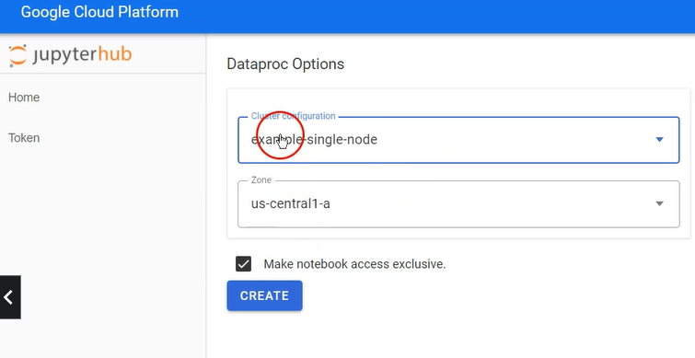

Now we can see cluster created under cluster option🡪

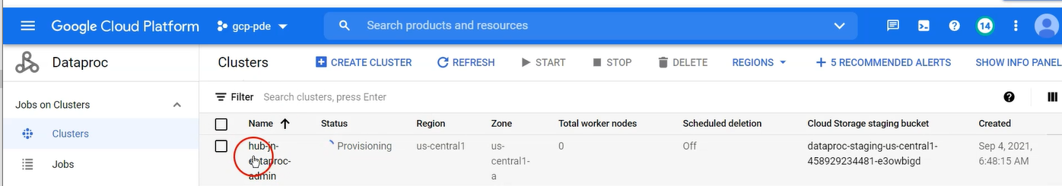

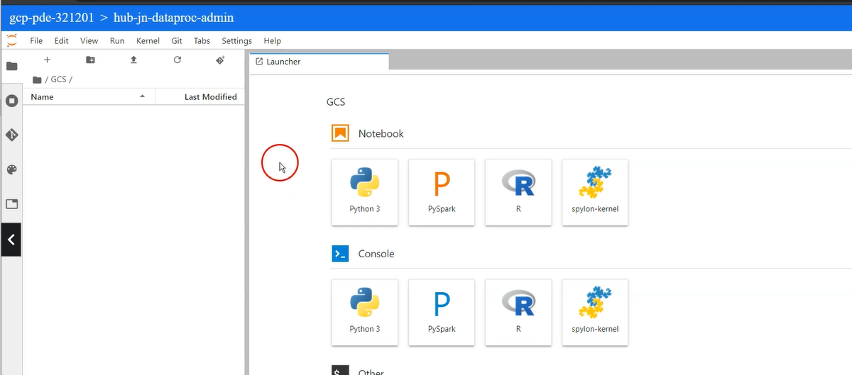

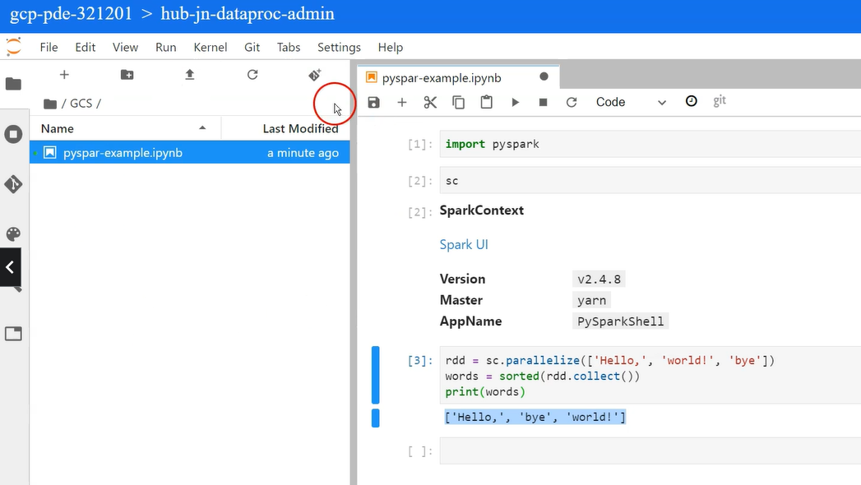

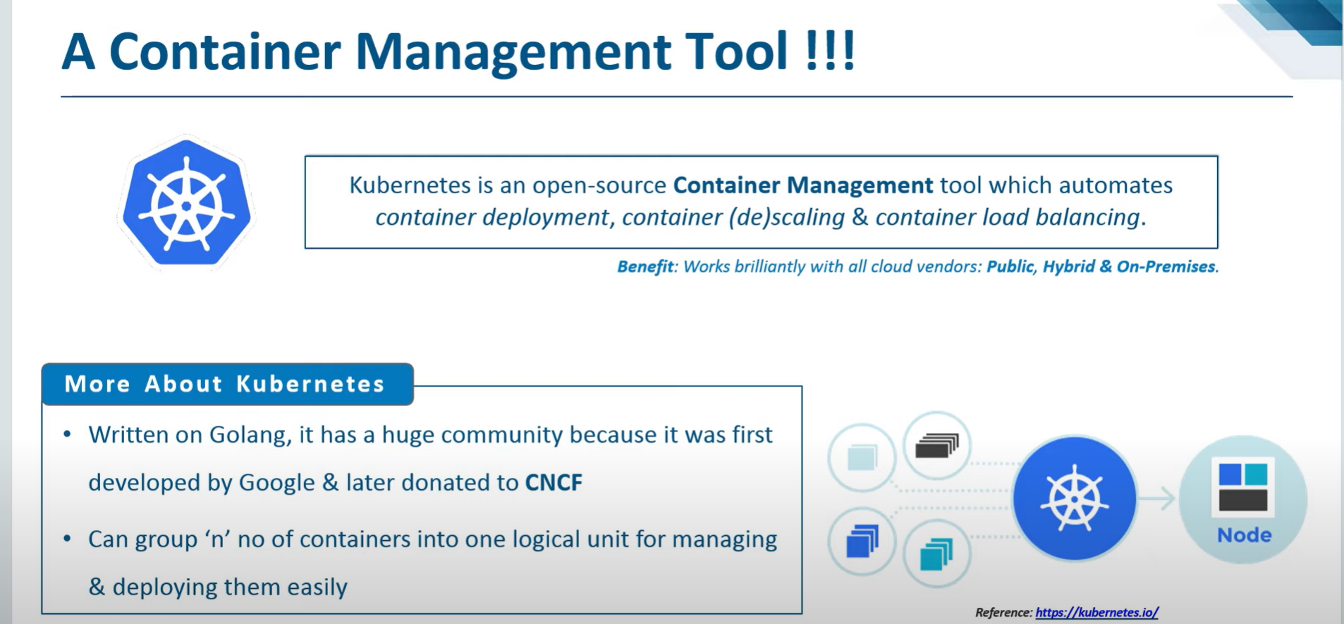

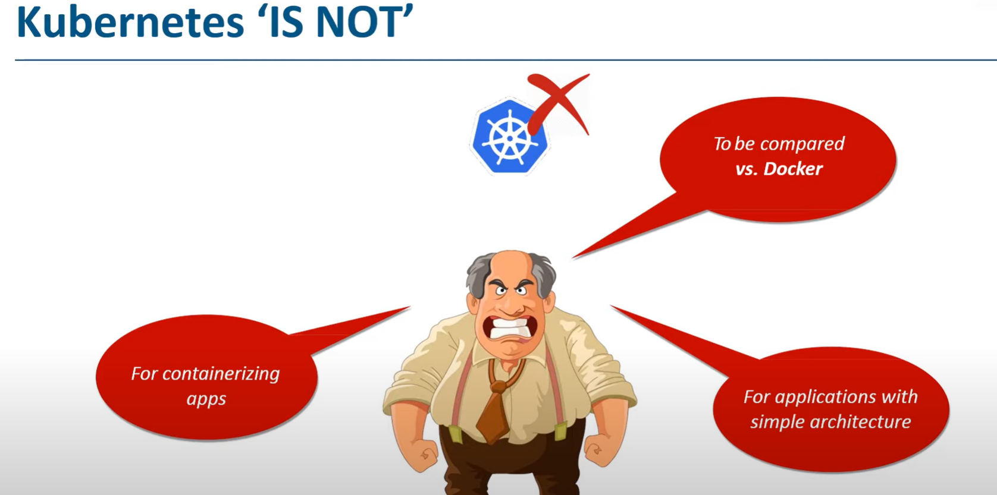

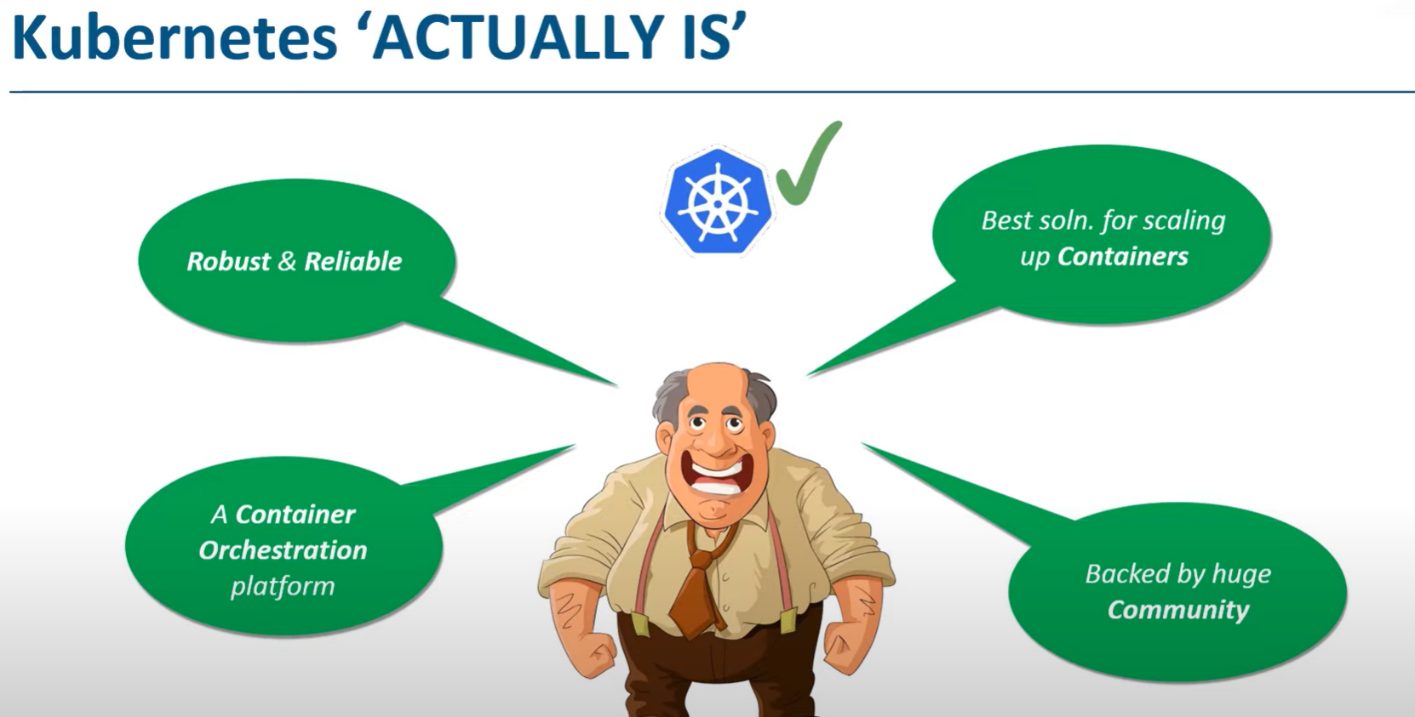

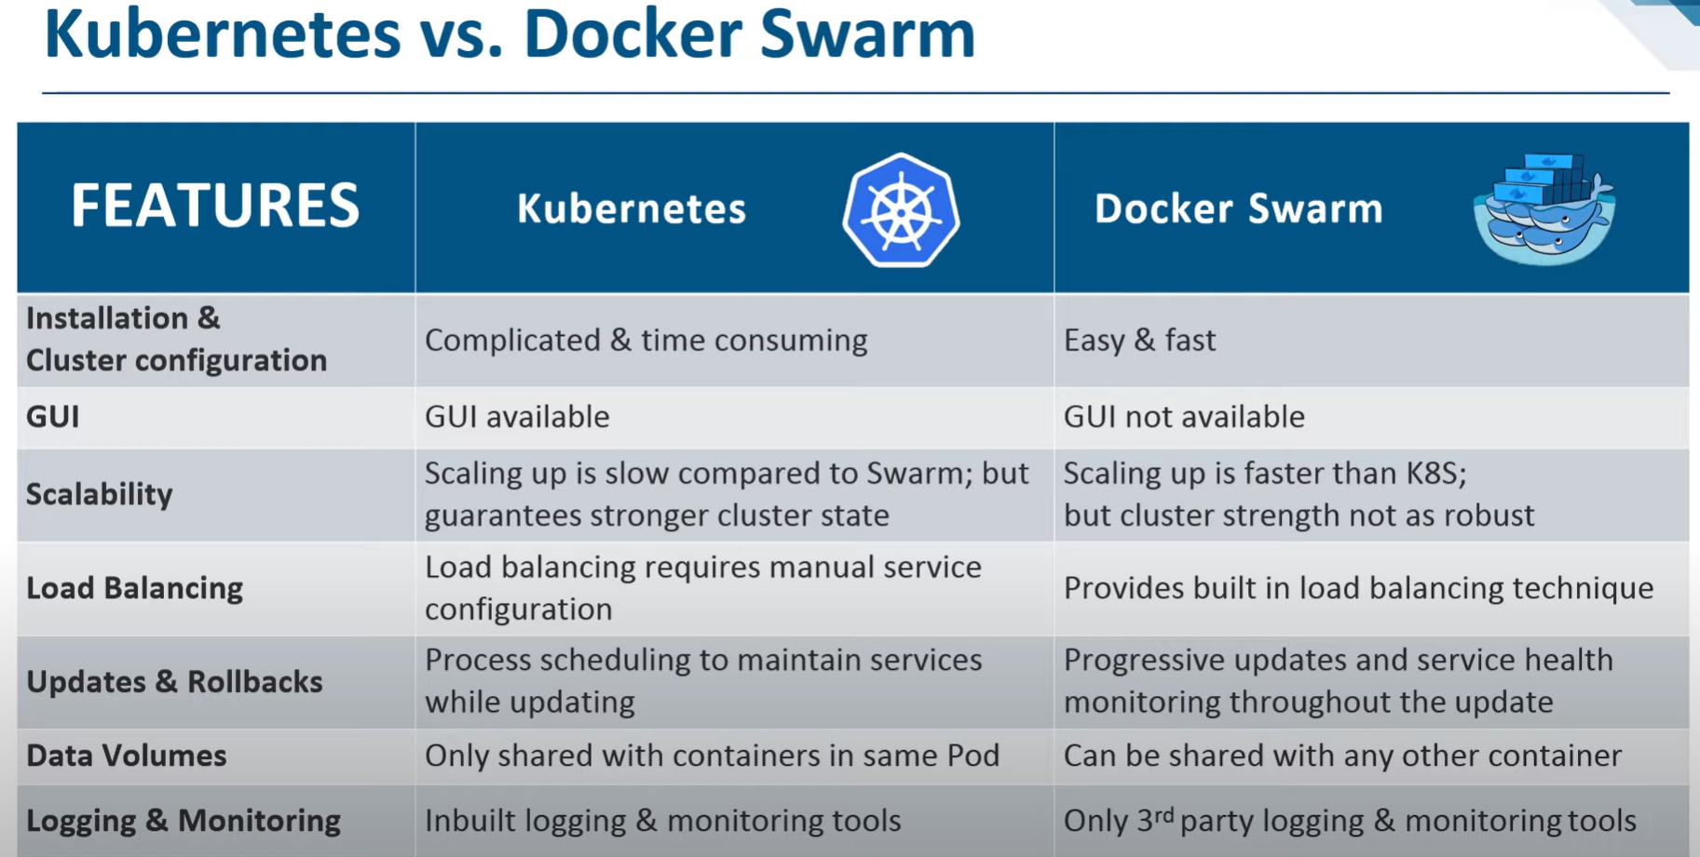

gcloud container clusters get-credentials cluster-shjo --zone us-central1-c --project fifth-honor-346418

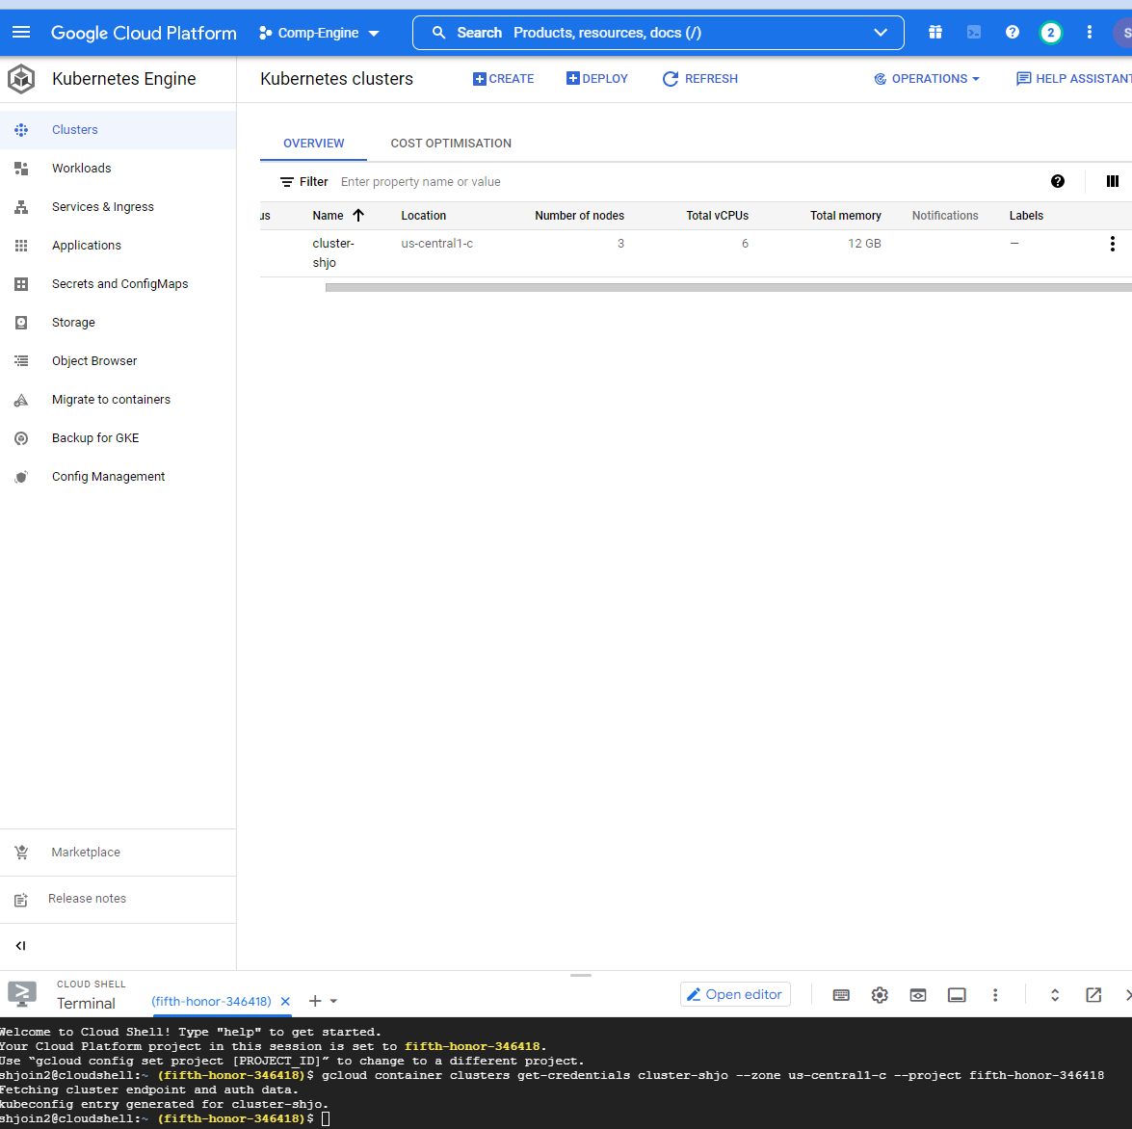

Welcome to Cloud Shell! Type "help" to get started.

Your Cloud Platform project in this session is set to fifth-honor-346418.

Use “gcloud config set project [PROJECT_ID]” to change to a different project.

shjoin2@cloudshell:~ (fifth-honor-346418)$ gcloud container clusters get-credentials cluster-shjo --zone us-central1-c --project fifth-honor-346418

Fetching cluster endpoint and auth data.

kubeconfig entry generated for cluster-shjo.

shjoin2@cloudshell:~ (fifth-honor-346418)$ kubectl get nodes

NAME STATUS ROLES AGE VERSION

**gke-cluster-shjo-default-pool-aebd7a85-3nhv Ready <none> 2m42s v1.21.6-gke.1503**

**gke-cluster-shjo-default-pool-aebd7a85-f2n0 Ready <none> 2m42s v1.21.6-gke.1503**

**gke-cluster-shjo-default-pool-aebd7a85-j3pr Ready <none> 2m42s v1.21.6-gke.1503**

shjoin2@cloudshell:~ (fifth-honor-346418)$

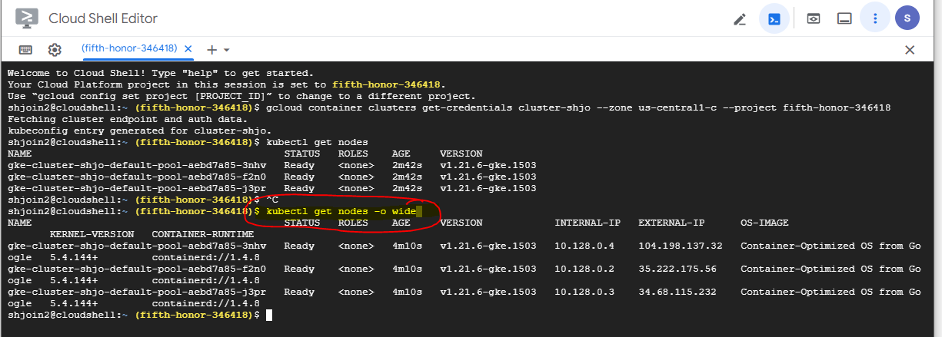

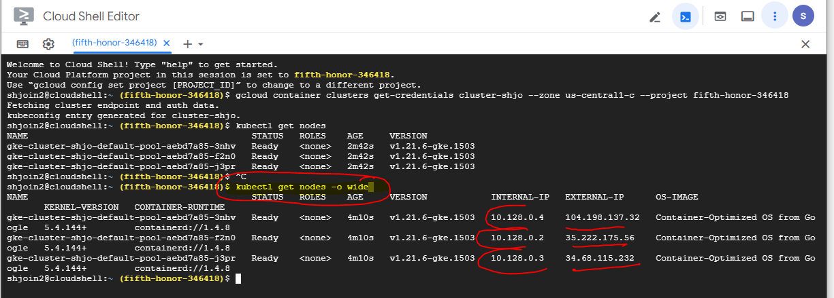

POD🡪





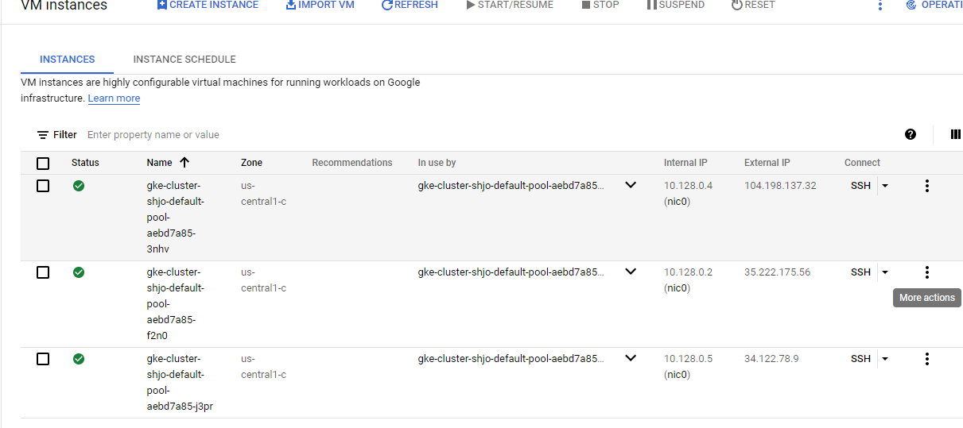

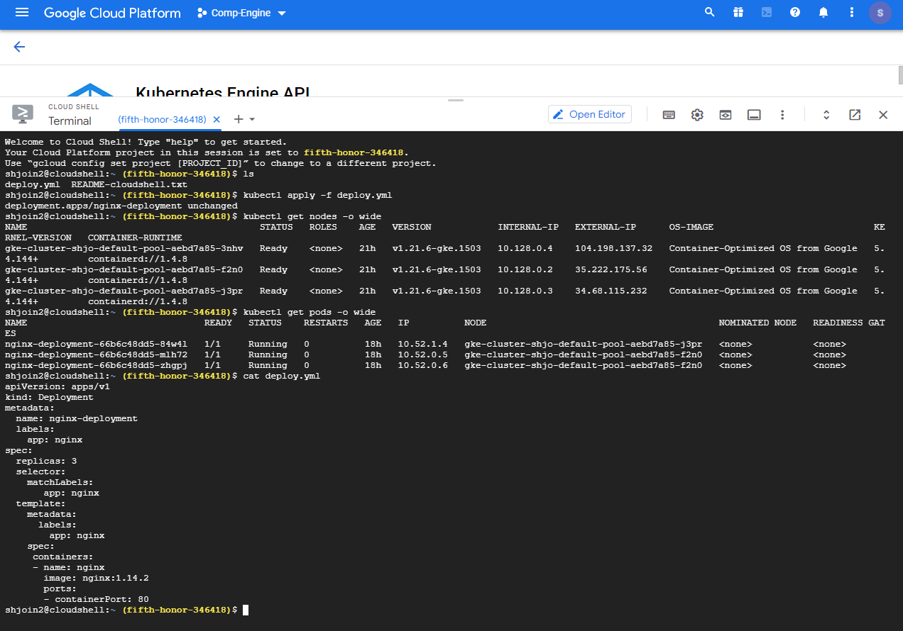

Cluster Size is 3 so three nodes

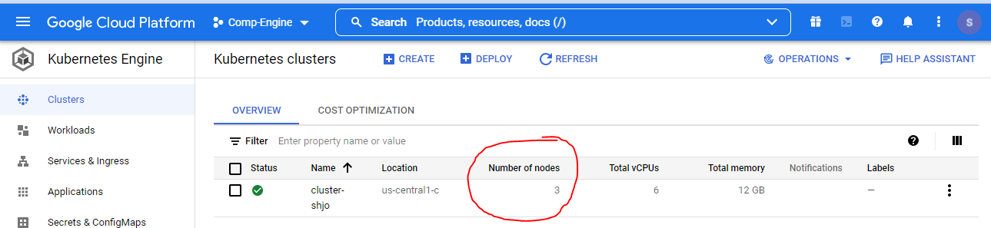



They don’t give us details of Master node it controls by google itself .

Now we need to create pods in each node .



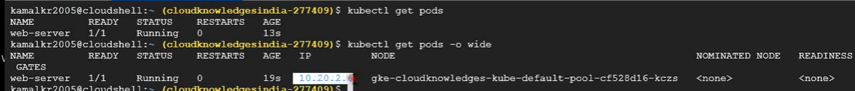

We can delete any pod

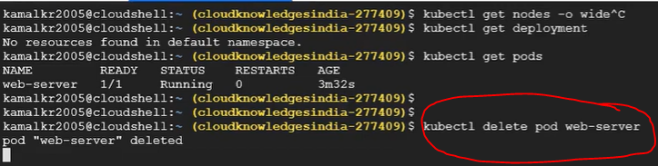

Pods🡪

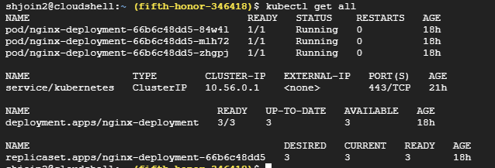

We need to create a service for this deployment

And service type is loadbalancer .

And google will create a load balancer like below and connect with all three node and assign a IP on Load balancer.

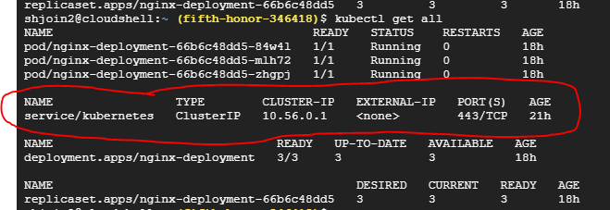

Default service , cluster ‘s service

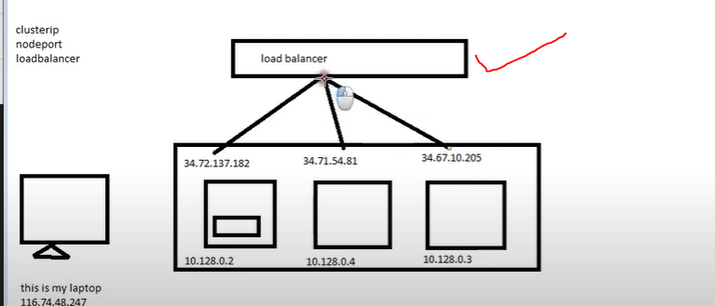



kubectl expose deployment nginx-deployment --type=LoadBalancer --port=80

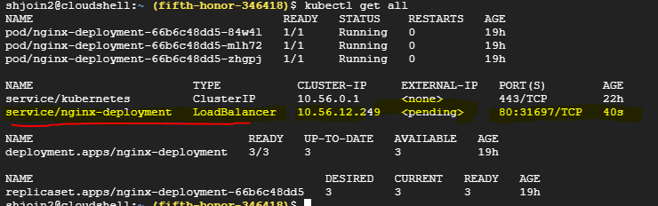

Loadbalancer’s ip is creating as above

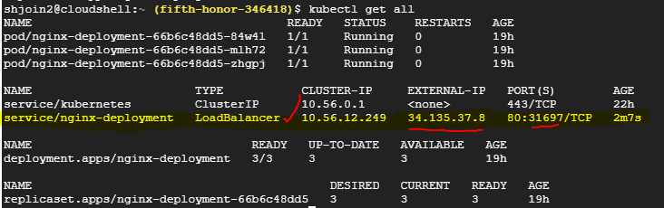

Node port 31697

When we create service (type is loadbalancer) from deployment ,and

It created node port and cluster IP (10.56.12.249 )+ load balancer ip (34.135.37.8) as well .

reference🡪

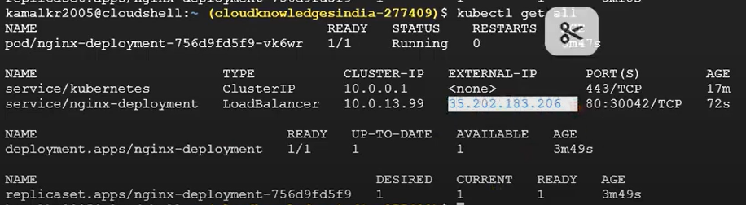

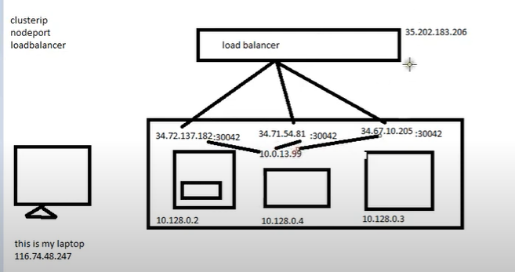



.

Pods are running in nodes gke-cluster-shjo-default-pool-aebd7a85-j3pr ,

gke-cluster-shjo-default-pool-aebd7a85-f2n0

gke-cluster-shjo-default-pool-aebd7a85-f2n0

**The number of nodes is estimated by the number of Compute VM instances because the Kubernetes control plane did not respond, possibly due to a pending upgrade or missing IAM permissions.**

**The number of nodes in a cluster should match the number of Compute VM instances, except for:**

* **A temporary skew during resize or upgrade**
* **Uncommon configurations in which nodes or instances were manipulated directly with Kubernetes and/or Compute APIs**

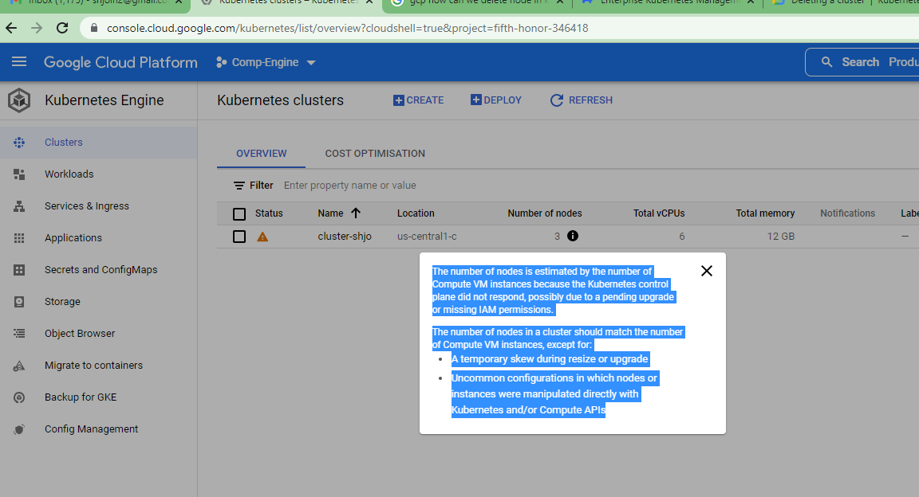

Qeteion GKE

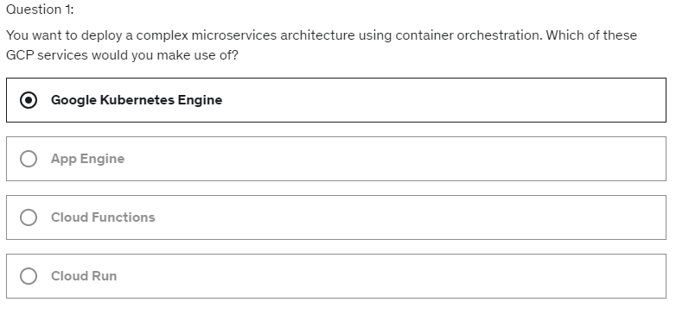

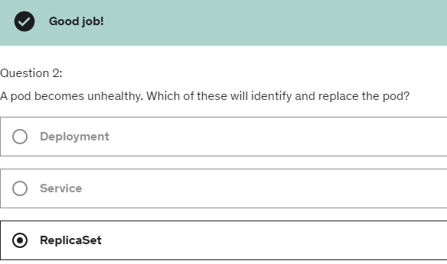

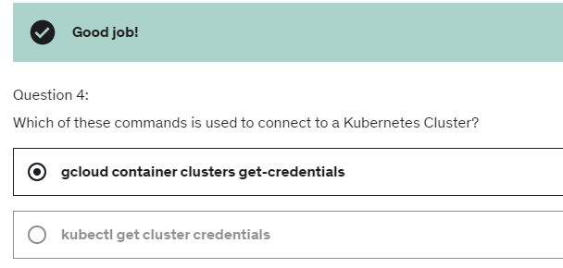

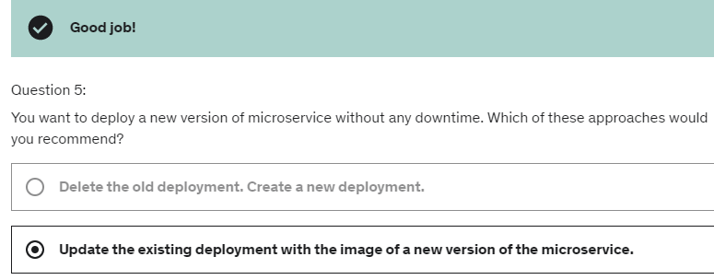

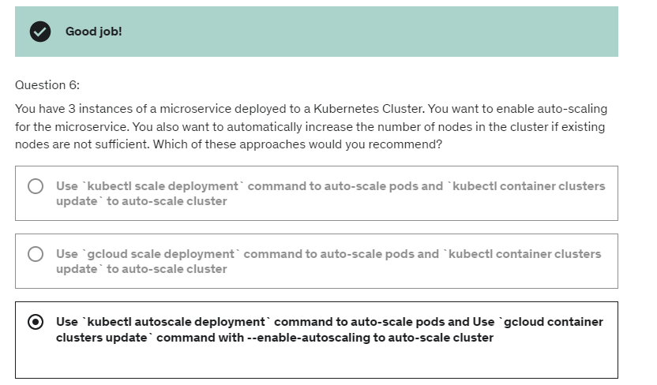

GKE cluster have no of node pools and node pools contains node and node are where you have instances of your applications are deployed . 



Can we create multiple pods in one container ? wrong que

Can we create multiple container in a pod ?

**If you want go with the Pod# webserver**

**kubectl exec -it webserver – sh**

**We are in a container # WEB because we have only one container in a pod webserver .**

**Kubectl exec -it -c web webserver – sh**

How to create cluster with yml

How to delete GKE with YML